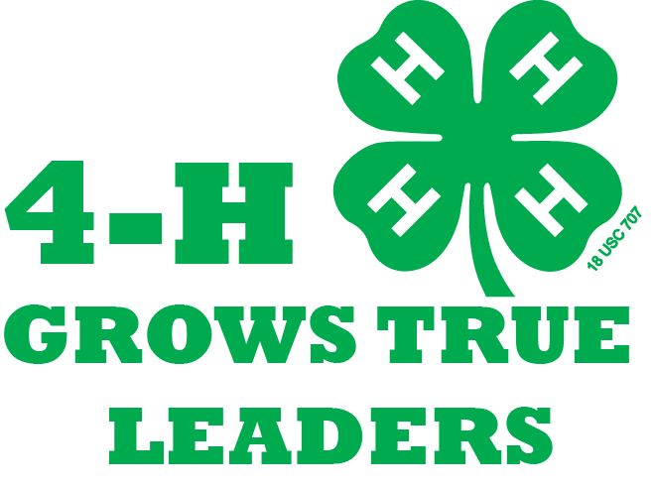

The Faces of Fall Forum

Wisconsin 4-H Leadership Council Members
You may see these people around with matching polos and shirts; they are members of the Wisconsin 4-H Leadership Council, a state team that helps plan and host many statewide 4-H events and programs, including Fall Forum. Feel free to ask them any questions about anything!
Presenters
These are fantastic volunteers and staff from all over the state who have donated their time to lead sessions on varying topics. Make sure to thank the presenters of your seminars for their time, and ask them questions about their field!
Participants
Adult and youth volunteers from all over the state have gathered here for Fall Forum, and they all have at least one thing in common... 4-H! Make sure to mingle and meet new people this weekend because you never know what kinds of connections and friendships you can make!
Laureates
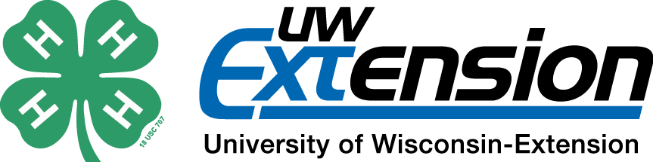
Laureates are dedicated 4-H volunteers, 4-H Foundation donors, notable 4-H alumni, and UW-Extension staff that have gone through an extensive nomination process to be inducted into the 4-H Hall of Fame. They are being recognized for their endless dedication to Wisconsin 4-H! Make sure to thank them for everything they have given to 4-H and be sure to attend the 4-H Hall of Fame Celebration on Saturday night.

