Wisconsin Native Plants for Raingardens
from: Applied Ecological Services
17921 Smith Rd., Brodhead, WI, 53520
(608) 897-8641 • www.appliedeco.com
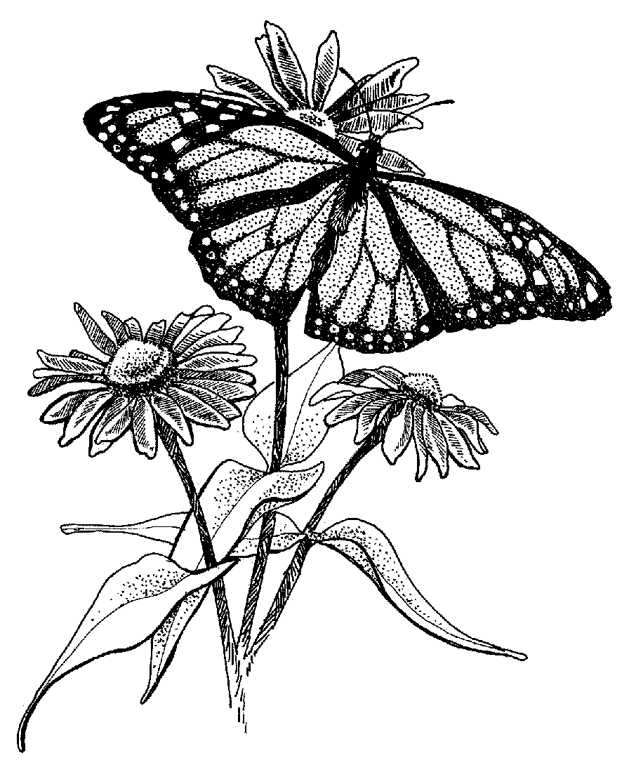

Habitat Key:

W-Wetland WP-Wet Prairie MP-Mesic Prairie
S-Savanna DP-Dry Prairie WD-Woodland

Butterfly Favorites
* Hummingbird favorite

Scientific Name | Common Name | Height | Color | Bloom Time | Habitat
Allium cernuum | nodding wild onion | 1-2' | pink/white | July-Aug | MP/WD/S | 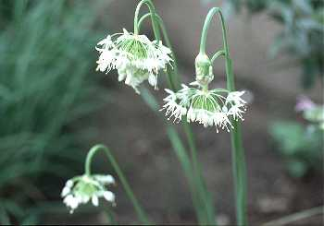
Amorpha canescens | leadplant | 1-3' | dusty purple | June-Aug | MP/DP | 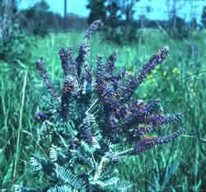
Apocynum androsaemifolium | dogbane | 6-24" | pink striped | June-Aug | MP/WD/S | 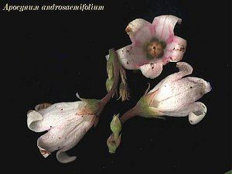
Aquilegia canadensis | columbine* | 1-3' | red & yellow | May-June | MP/WD/S | 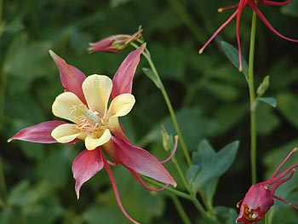
Asclepias incarnata | red milkweed | 2-8' | magenta | July-Aug | WP/W | 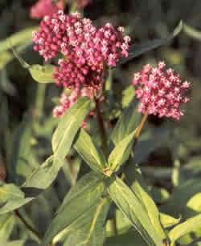
Asclepias syriaca | common milkweed | 2-4' | dusty pink | June-Aug | MP | 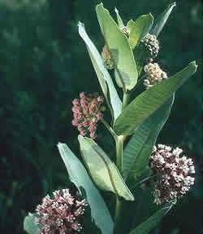
Asclepias syriaca | butterfly weed* | 1-3' | orange | July-Sept | DP/S | 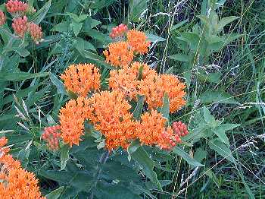
Aster azureus | sky blue aster | 6-24" | azure | Aug-Oct | MP/DP | 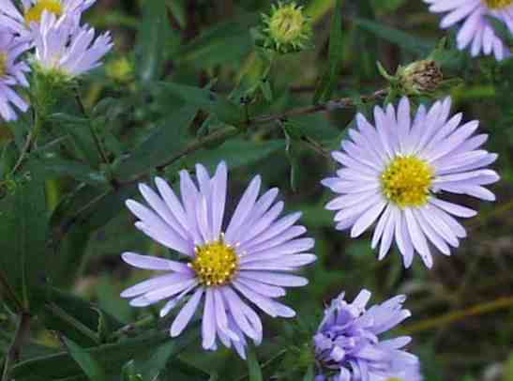
Aster ericoides | heath aster | 1-3' | white | Aug-Oct | DP | 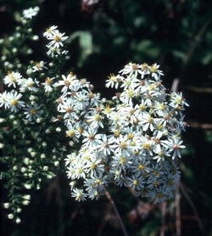
Aster novae-angliae | New England aster | 1-4' | purple & orange | Aug-Oct | WP/MP | 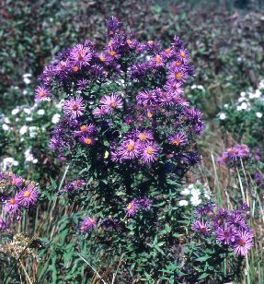
Aster sericeus | silky aster | 1-2' | lavender | Aug-Oct | DP/MP | 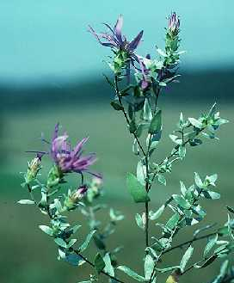
Ceanothus americanus | New Jersey tea* | 1-3' | white | June-Aug | DP/MP | 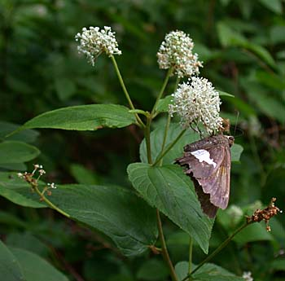
Chelone glabra | turtlehead | 1-3' | white | July-Sept | WP/W | 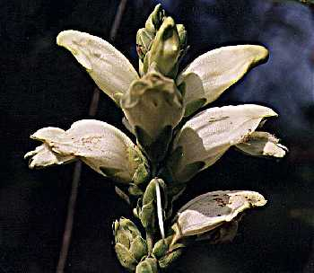
Cirsium discolor | native field thistle | 3-9' | pink/red | July-Oct | MP/DP/S | 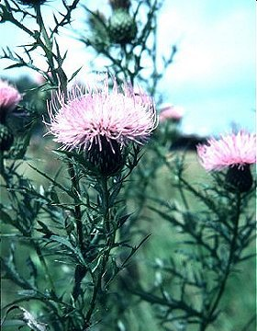
Echinacea pallida | pale purple coneflower | 2-4' | pink/purple | June-July | MP/DP | 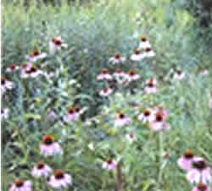
Echinacea purpurea | purple coneflower | 2-3' | purple | June-Oct | MP/D | 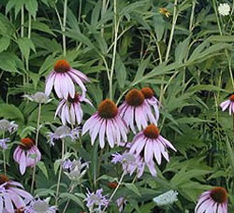
Eryngium yuccifolium | rattlesnake master | 1-4' | white/green | July-Aug | DP/MP | 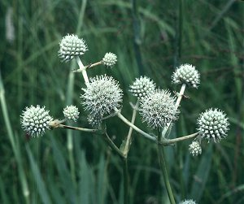
Eupatorium maculatum | spotted Joe Pye | 2-6' | pink | July-Sept | W/WP | 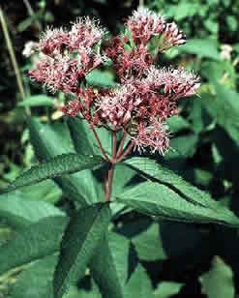
Eupatorium perfoliatum | boneset | 2-4' | white | July-Oct | MP/WP | 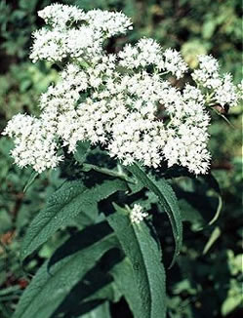
Eupatorium purpureum | savanna JoePye | 3-6' | dusty pink | July-Aug | WP/MP/S | 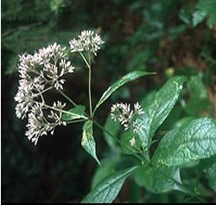
Liatris aspera | rough blazing star* | 2-3' | purple/pink | Aug-Oct | MP/DP | 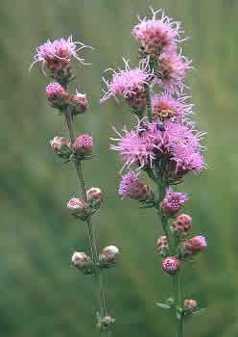
Liatris pycnostachya | prairie blazing star* | 2-4' | purple | July-Sept | WP/MP | 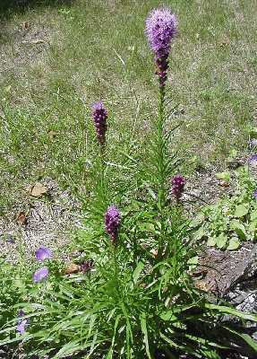
Lobelia cardinalis | cardinal flower* | 2-4' | scarlet | July-Sept | W/WP | 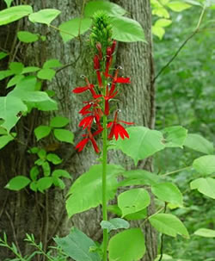
Lobelia siphilitica | great blue lobelia | 1-4' | blue | Aug-Sept | W/WP | 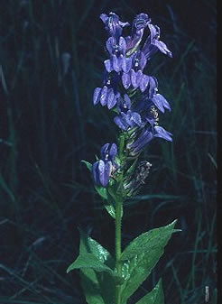
Monarda fistulosa | bergamot | 2-4' | lavender/pink | July-Aug | WP/MP | 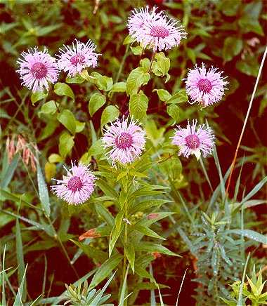
Petalostemum purpureum | purple prairie clover | 1-2' | purple | June-Aug | DP/MP | 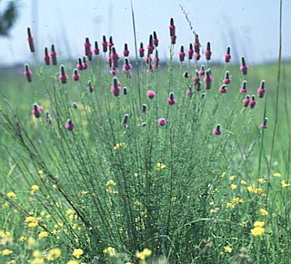
Phlox divaricata | woodland phlox | 6-12" | blue | April-June | WP/DP | 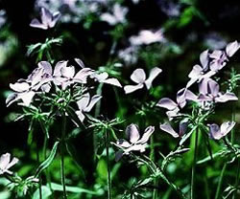
Phlox pilosa | downy prairie phlox | 6-18" | pink | April-June | DP/MP/S | 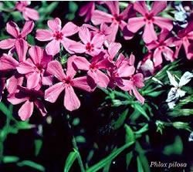
Pycnanthemum virginianum | mountain mint | 1-4' | white | July-Sept | WP/MP | 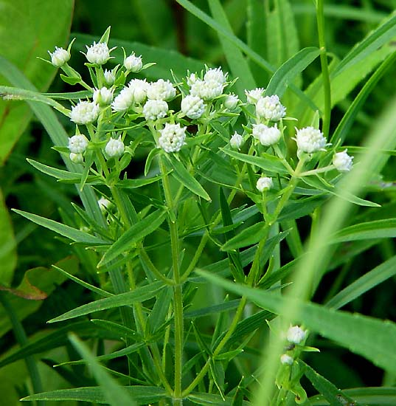
Rudbeckia hirta | black-eyed Susan | 1-3' | yellow & brown | June-Aug | DP/MP | 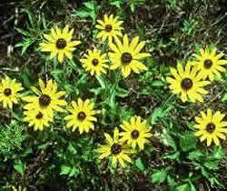
Solidago riddellii | Riddell’s goldenrod | 1-3' | yellow | Aug-Oct | W/WP | 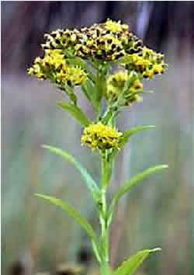
Solidago rigida | stiff goldenrod | 1-4' | yellow | July-Oct | MP/DP | 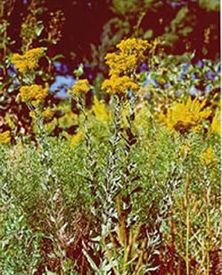
Solidago speciosa | showy goldenrod | 1-3' | yellow | Aug-Oct | MP/DP | 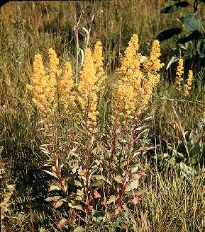
Spiraea alba | meadowsweet | 2-5' | white | June-Sept | WP/W | 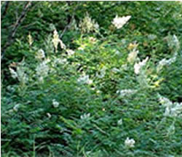
Tradescantia ohiensis | spiderwort | 1-4' | blue | April-July | MP/WP/S | 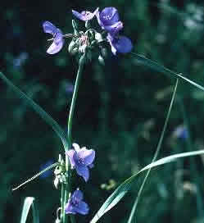
Verbena hastata | blue vervain | 2-4' | purple | July-Oct | W/WP | 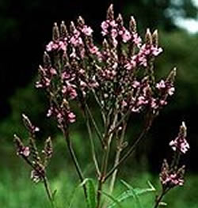
Verbena stricta | hoary vervain | 1-2' | blue/purple | July-Sept | MP/DP | 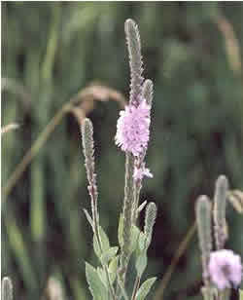
Vernonia fasciculata | ironweed | 3-5' | royal purple | July-Sept | WP/W | 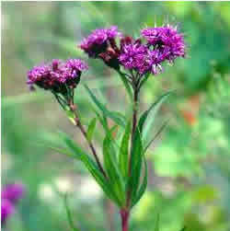
Veronicastrum virginicum | culver's root | 3-5' | white | July-Aug | MP/WP | 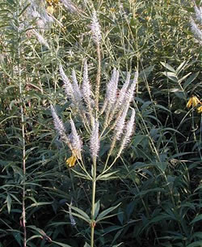
Viola papilionacea | common wood violet | 2-6" | purple/white | April-June | S/WD | 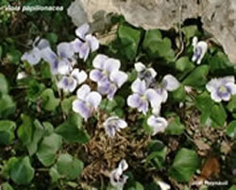
Viola pedata | birdsfoot violet | 2-6" | purple & yellow | April-June | DP/MP/S | 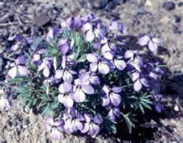
Zizia aptera | heartleaved golden Alexander | 1-2' | yellow | May-June | MP/DP | 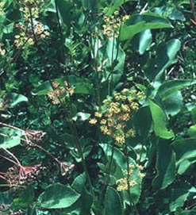
Zizia aurea | divided golden Alexander | 1-2' | yellow | May-June | WP/W | 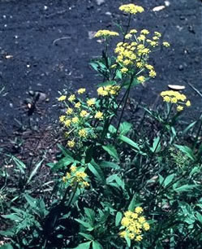

(continued)

Bird Feeders - Forbs
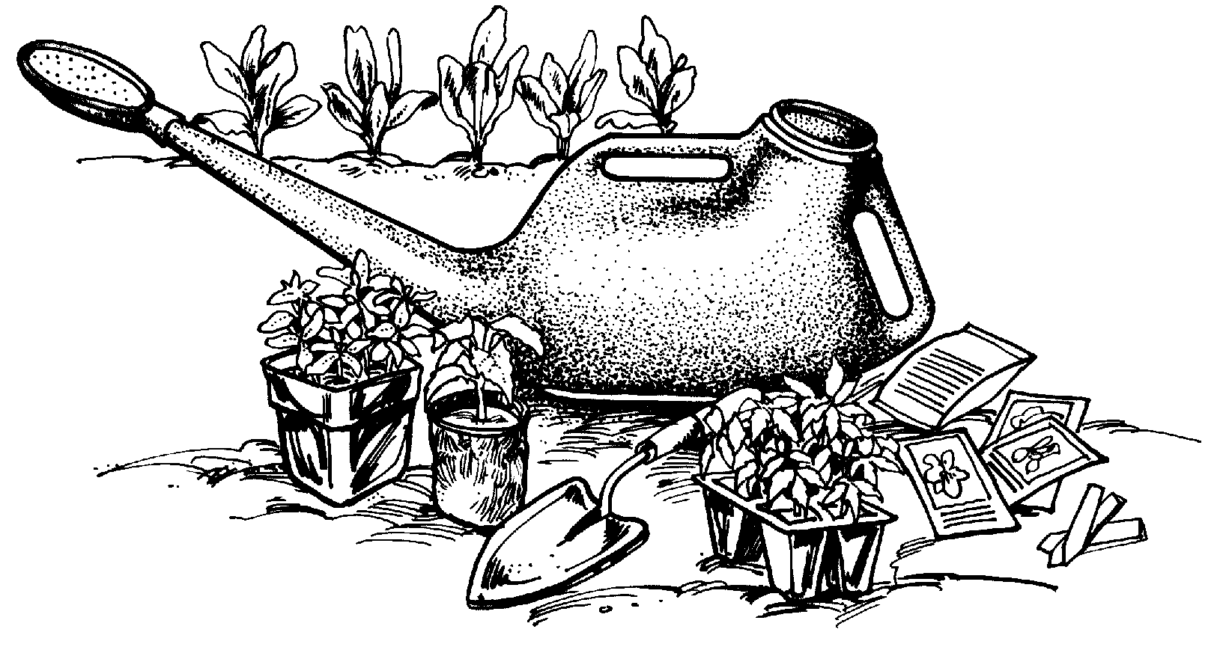

Scientific Name | Common Name |  | Height |  | Color |  | Bloom Time |  | Habitat
Aster ericoides |  | heath aster |  | 1-3' |  | white |  | Aug-Oct |  | DP |  | 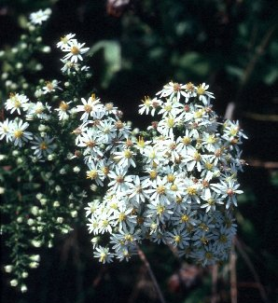
Aster sericeus |  | silky aster |  | 1-2' |  | lavender |  | Aug-Oct |  | DP/MP |  | 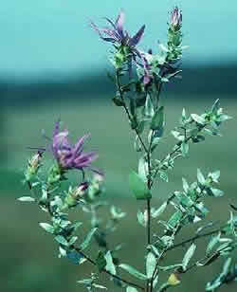
Astragalus canadensis |  | Canada milk vetch |  | 1-4' |  | yellow |  | June-Aug |  | WP/MP/S |  | 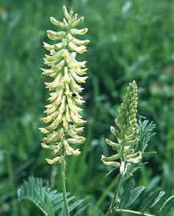
Campanula rotundifolia |  | harebell |  | 6-12" |  | blue |  | June-Oct |  | MP/S/WD |  | 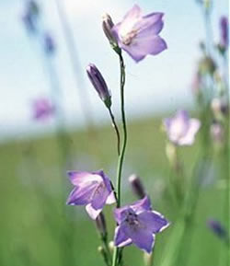
Cassia hebecarpa |  | wild senna |  | 3-6' |  | yellow |  | July-Aug |  | W/WP |  | 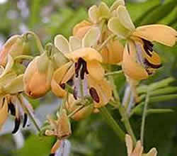
Cirsium discolor |  | native field thistle |  | 3-9' |  | pink/red |  | July-Oct |  | MP/DP/S |  | 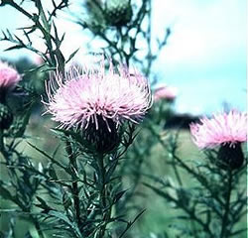
Desmodium canadense |  | showy tick-trefoil |  | 3-4' |  | purple |  | July-Aug |  | MP/DP/S |  | 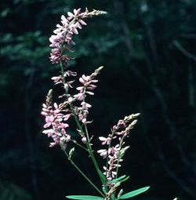
Desmodium illinoense |  | Illinois tick-trefoil |  | 3-5' |  | purple/pink |  | July-Aug |  | MP/DP/S |  | 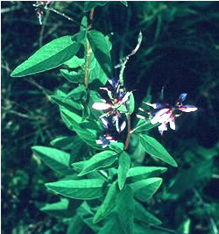
Epilobium angustifolium |  | fireweed* |  | 3-7' |  | pink/red |  | June-Sept |  | WP/W |  | 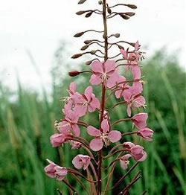
Fragaria virginiana |  | wild strawberry |  | 4-6" |  | white |  | April-June |  | MP /DP/S |  | 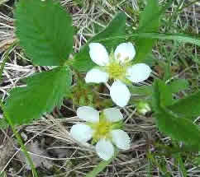
Geum triflorum |  | prairie smoke |  | 6-12" |  | burgundy/pink |  | April-June |  | DP/MP |  | 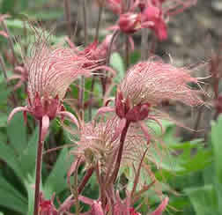
Helenium autumnale |  | sneezeweed |  | 2-4' |  | yellow |  | Aug-Oct |  | W/WP |  | 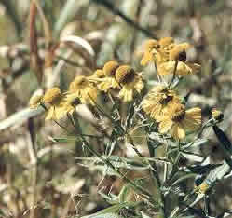
Helianthus laetiflorus |  | showy sunflower |  | 1-4' |  | yellow |  | Aug-Sept |  | MP |  | 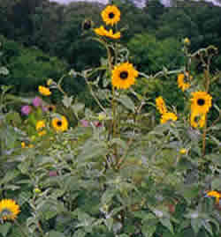
Helianthus mollis |  | downy sunflower |  | 2-4' |  | yellow |  | Aug-Sept |  | MP/DP/S |  | 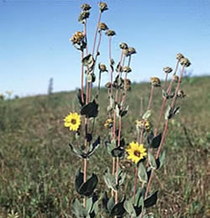
Helianthus occidentalis |  | ox-eye sunflower |  | 2-3' |  | yellow |  | Aug-Sept |  | MP/DP |  | 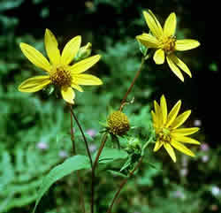
Heliopsis helianthoides |  | fa1se sunflower |  | 2-5' |  | yellow |  | July-Sept |  | MP/DP |  | 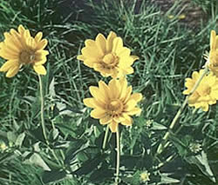
Iris shrevei |  | wild iris* |  | 1-3' |  | purple & yellow |  | May-July |  | MP/WP/W |  | 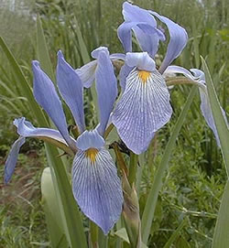
Lespedeza capitata |  | roundhead bush clover |  | 2-4' |  | ivory |  | July-Sept |  | MP/DP |  | 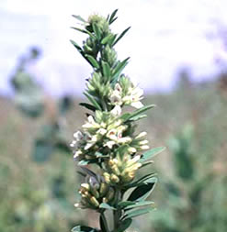
Liatris aspera |  | rough blazing star |  | 2-3' |  | purple/pink |  | Aug-Oct |  | MP/DP
Liatris pycnostachya |  | prairie blazing star* |  | 2-4' |  | lavender |  | July-Sept |  | WP/MP |  | 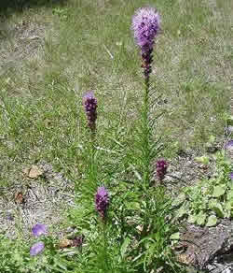
Oenothera biennis |  | evening primrose |  | 2-5' |  | yellow |  | July-Oct |  | MP/DP |  | 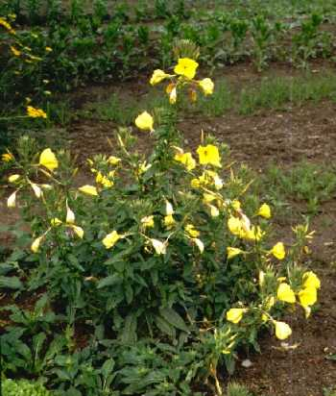
Penstemon digitalis |  | bearded foxglove |  | 1-4' |  | white |  | May-July |  | MP/DP |  | 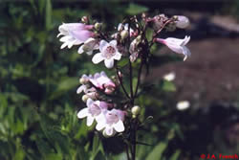
Petalostemum purpureum |  | purple prairie clover |  | 1-2' |  | purple |  | June-Aug |  | DP/MP
Ratibida pinnata |  | yellow coneflower |  | 1-4' |  | yellow & brown |  | June-Aug |  | WP/MP/DP |  | 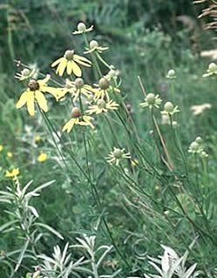
Rosa sp. |  | wild rose |  | 6-18' |  | pink |  | June-July |  | MP/DP/S |  | 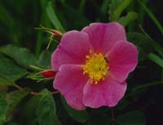
Rudbeckia hirta |  | black-eyed Susan |  | 1-3' |  | yellow & brown |  | June-Aug |  | DP/MP
Rudbeckia triloba |  | brown-eyed Susan |  | 1-4' |  | yellow & brown |  | July-Oct |  | WD/S |  | 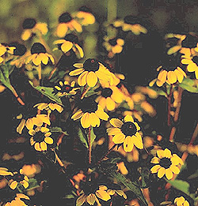
Ruellia humilis |  | wild petunia* |  | 6-18" |  | purple |  | June-Aug |  | DP/MP |  | 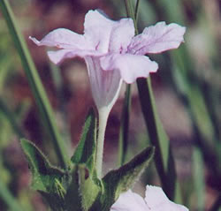
Silphium integrifolium |  | rosin weed |  | 2-6' |  | yellow |  | July-Sept |  | MP |  | 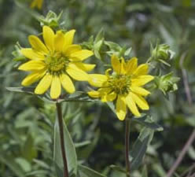
Silphium laciniatum |  | compass plant |  | 3-7' |  | yellow |  | June-Sept |  | WP/MP |  | 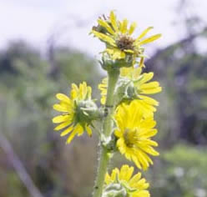
Silphium perfoliatum |  | cup plant* |  | 3-7' |  | yellow |  | July-Sept |  | WP |  | 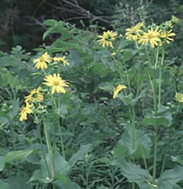
Silphium terebinthinaceum |  | prairie dock |  | 3-8' |  | yellow |  | July-Sept |  | MP/DP |  | 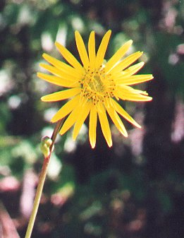
Solidago riddellii |  | Riddell’s goldenrod |  | 1-3' |  | yellow |  | Aug-Oct |  | W/WP

(continued)

Bird Feeders - Grasses
Scientific Name | Common Name | Height | Color | Bloom Time | Habitat
Andropogan gerardii | big bluestem | 4-7' | purple & green | Aug-Nov | WP/MP | 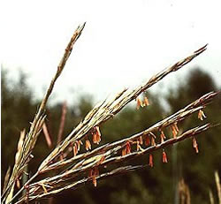
Andropogon scoparius | little bluestem | 1-3' | rust & green | Aug-Oct | MP/DP | 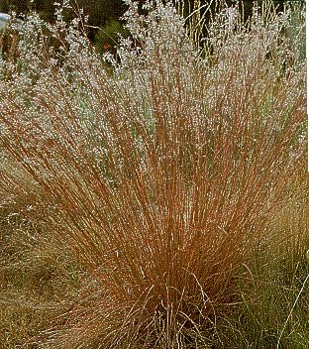
Bouteloua curtipendula | side-oats grama | 1-3' | purple & gold | Aug-Oct | MP/DP | 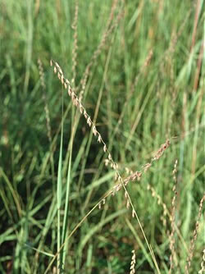
Panicum virgatum | switch grass | 3-5' | gold | Aug-Oct | MP/DP | 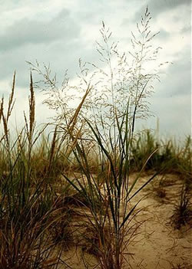
Sorghastrum nutans | Indian grass | 3-6' | copper & green | Aug-Oct | MP/DP | 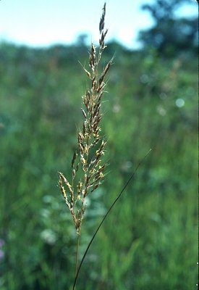
Sporobolus heterolepis | prairie dropseed | 2-4' | gold | Sept-Nov | MP/DP | 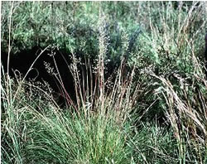

Photos from: U.W. Herbarium http://www.botany.wisc.edu/wisflora/Specimensearch.html

