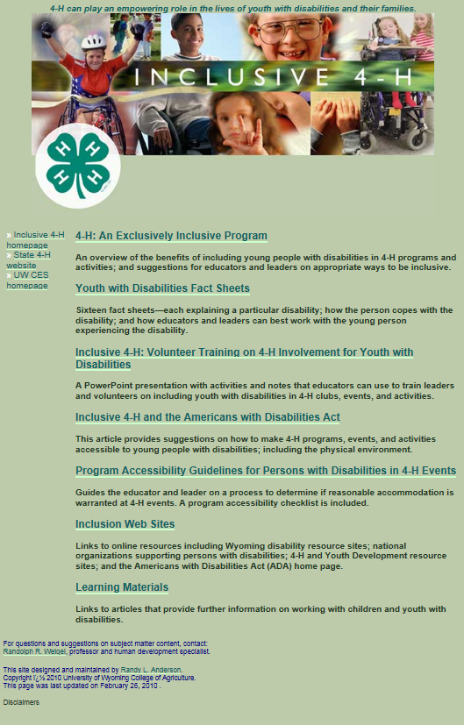

University of Wyoming 4-H: http://www.uwyo.edu/4-h/volunteers/inclusive/files/

