“It was a great professional development opportunity! I appreciated the variation in teaching approaches and the chance to chat with peers on the discussion board.”
“……I am definitely gaining new knowledge and skills out of the course.” Feedback from Participants

National Professional Development Opportunity:
January 23 – March 5, 2018
Volunteers are fundamental to many successful Extension programs. Research indicates that nearly one third of volunteers will choose not to continue volunteering based on poor management practices.

Achieving the Extension Mission Through Volunteers is an online cohort course for the novice and experienced professional working with volunteers to enhance and deliver Extension programs. It is designed to:
- Build staff and organizational capacity around volunteer management and development
- Increase volunteer management competencies
- Build knowledge and skills to identify, recruit, select, and support volunteers
- Learn current volunteer trends and how they may impact programming
- Understand the organization’s philosophy related to volunteerism and develop your own philosophy

Registration will open mid-summer for North Central Region staff. After October 20 the course will open nationally to Extension staff. A cohort will be 30-40 individuals from across program areas. Space is limited. This course is being brought to you by the North Central Region 4-H Youth Development Volunteer Specialists. Course is recommended for staff with at least one year of experience. Experienced staff members have found this very valuable as well. “This has been one the most useful professional development experiences I have had in my 18 years of working in Extension.” “I will be suggesting this course to my colleagues!”
During this 6-week course members participate in pre-recorded sessions, readings, activities and 3 live webinars, interact with a wide variety of resources and hear from experts. The course is led by a facilitator team. Each module will require approximately 4 - 6 hours each week. Guest contributors include:
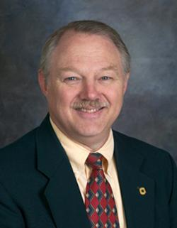
Jim Rutledge, Ph.D., Adjunct Professor and Executive Director 4-H Foundation, Inc. 4-H Foundation
Development Manager at Oklahoma State University

Dr. Rutledge shares his work on the professional development stages of the Extension professional and helps cohort members discover how THEIR professional development stages influence their capacity to reach larger audiences with more valuable educational programs.
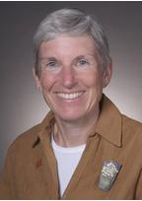
Nancy Franz, Ph.D., Professor Emeritus, School of Education at Iowa State University

Dr. Franz discusses personal, organizational, and public value related to volunteers in Extension. She has done extensive work on Communicating Value and its importance for Extension and its volunteers.

This course is available for $250. (As a North Central regional project, this course will be offered to staff in the North Central Region for $100.) To learn more: https://youtu.be/MKIVl8WBVkQ. Look for registration information this summer!

Please contact the Volunteer Specialist in your state if you have questions. Participants will be sent detailed course information once registration closes.

