****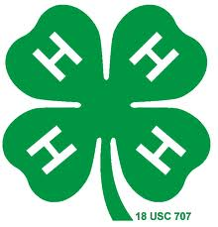

**Interest Interview Questions**

**Below are questions you can use to get to know the members of the club or group. These questions can help you learn what type of leadership experiences might be a good fit.**

1. **Tell me about a time that you worked in a group? This might be at school, other youth group or community group you belong to?**
2. **What did you enjoy most about the experience?**
3. **What was your role in the group?**
4. **If you could have done something different to help; what would it have been?**
5. **Was there something that someone else did that you thought you would like to try?**

**(OVER)**

1. **What is a hobby or project that you would be willing to tell others about?**
2. **What is something in the community that you think our club or group could get involved in?**
3. **Here is a list of ten things – what are 2-3 things that you might like to try out.**

* **Tell someone about my favorite project**
* **Be a greeter when people come to the meetings**
* **Be a buddy/mentor to a new member**
* **Teach a new game at a club meeting**
* **Be on a community service committee**
* **Be a member of any committee**
* **Be one of the leaders for a committee**
* **Be a helper at a workshop**
* **Be a teacher at a workshop**
* **Be a counselor for a day camp**

1. **If there is one thing our club/group could do to help people feel more welcome what would it be?**
2. **What is your favorite thing about 4-H?**
3. **What is one thing you would like to change about 4-H?**

**Thank you for sharing your thoughts and ideas. ______ (insert name), I look forward to working with you having you continue your involvement in ___________ club or group.**