Increasing Family Financial Capability
April 2012

Money $mart in Head Start participants report feeling less worried about finances and having less difficulty paying bills, plus they are 92% more likely to have a written budget than households not in the program. Households that participated in workshops and/or coaching reported even greater gains in managing debt and their ability to save than households receiving only the monthly financial newsletter.

For more information, contact:
fyi.uwex.edu/moneysmartheadstart

(insert your contact information here)

Project Overview
Research shows that programs designed to build financial capability—the ability to manage one’s resources based on knowledge, skills and access—can help families improve their long-term financial security. To help build the financial capability of Wisconsin families, community-based Head Start programs and Cooperative Extension family living educators and specialists are working together to provide financial education to low-income families through the Money $mart in Head Start (M$iHS) program.
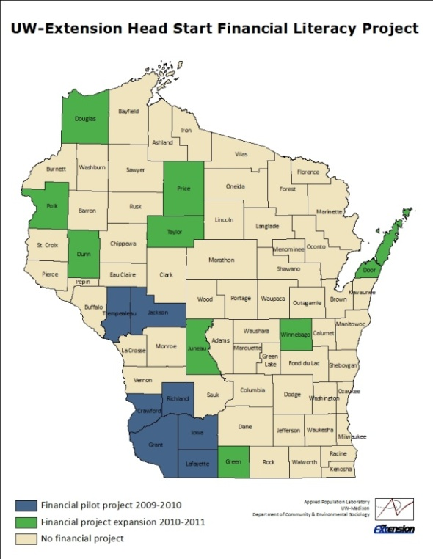
Beginning with the 2009-2010 school year, Cooperative Extension offices in seven counties formed partnerships with local Head Start programs on the M$iHS initiative.
The program expanded in the 2010-11 school year to more than 500 households with children enrolled in Head Start and Early Head Start in 16 Wisconsin counties.

The M$iHS program developed three financial capability-building strategies: 1) monthly newsletters; 2) financial education workshops; and 3) financial coaching. In order to participate in this project, families were asked to complete a baseline survey and consent form, followed by a second survey approximately 8 months later. To better understand which educational approaches most benefit families, one-fifth of the participating families received no additional financial literacy education, while the remaining families randomly received financial education in up to three forms based on their geographic location.

Baseline Survey Findings
Baseline surveys from approximately 500 households participating in the M$iHS program during the 2010-2011 school year underscore the population’s financial vulnerability:
• Two-thirds of respondents had annual take-home incomes of less than $20,000.
• Only 6% of respondents had a rainy day fund with 3 months’ worth of expenses – compared to 43% of Wisconsin’s population as a whole.
• 60% reported having difficulty paying some of their loans or debts. Further, 36% of respondents reported paying their bills late “almost always” or “often.”
• Nearly one-third had received three or more calls from a creditor in the last three months.
Monthly Newsletters
Newsletters are a relatively low-cost way to provide relevant, timely, and unbiased information. Written by UW-Extension family living educators, the eight monthly M$iHS newsletters encourage readers to set a financial goal during the first month, with subsequent issues highlighting financial management skills to help reach those goals. Newsletters are 2-pages long and each covers a different financial topic:
1) Setting goals
2) Creating a spending plan
3) Managing debt
4) Tax refunds and credits
5) Saving
6) Banking
7) Credit
8) Household organization and record keeping

Edits were made to the newsletters in year two based on assessment data from the pilot project. In addition, the M$iHS financial newsletters will be available in Spanish for the 2012-2013 school year. The following chart overviews findings surrounding the impact of the newsletters.

Reading the Money $mart in Head Start newsletters helped me to…

2011 Post survey results (N=153)
Financial Literacy Workshops
UW-Extension developed two financial workshops specifically for families in the M$iHS program. One workshop topic focuses on budgeting and saving, while the other topic is credit management. The workshops are designed to complement the information found in the monthly newsletters.

Between September 2009 and May 2011, UW-Extension family living educators in 11 participating counties offered 21 financial education workshops with approximately 135 participants. Depending on the preference and structure of Head Start partner agencies, workshops were offered during both daytime and evening hours, and also at a statewide Head Start conference. Educators conducted post-session surveys to gather feedback from participants, including comments such as:

- “This gave me some really good ideas on how to save my money.”
- “Thank you for the information. I actually have been attempting to do this myself, but these tools will make it a lot easier.”
- “This information was fantastic for any person who needs to try to find a few more dollars in their pocket.”
- “This session made me look at my spending differently. Good ideas!”
- “The presenters were wonderful and helped me so much. This was such an excellent learning tool that will change my life.”

Financial Coaching
Coaching is a collaborative process in which the coach and an individual work together to reach the individual’s long-term financial goals. Coaches help people to refine their goals to be specific, measurable, realistic, and time bound. Coaches then hold people accountable to the goals that each person sets for themselves. Because coaching involves one-on-one meetings over time, it is a fairly resource-intensive intervention, but has potential to help those individuals who need and seek out additional support. The idea behind financial coaching, in addition to newsletters and workshops, is that even though people seek to change their behavior based on what they learn, they often struggle to follow through on actions. Between 2009-2011, family living educators in eight M$iHS counties provided financial coaching for 24 households working toward achieving their financial goals.

The baseline survey covered a range of topics, including whether respondents were interested in working with a financial coach to reach their goals. This chart compares the survey responses of those who were interested in coaching versus those who were either not interested in or unsure about coaching. Overall, about one-third (36%) expressed interest in working with a financial coach.

These two groups were equally confident in achieving their goals, although mean confidence in achieving goals was low for both groups. Beyond this finding, there were significant differences between the respondents interested in coaching and those who were either uninterested or unsure.

Parents who reported an interest in coaching:
- Were more likely to have a financial goal (verified in the survey by asking respondents to write down that goal).
- Were less confident in their ability to save and budget.
- Appeared to face more challenges with approximately 72% reporting more difficulty in paying their loans or debts vs. 53% of those not interested or unsure about coaching.
- Reported greater financial stress.

Overall, these results are consistent with the concept that individuals interested in coaching have financial goals, but that they have struggled to change their financial behaviors.
Follow-up Survey Findings
During the 2010-2011 school year, 187 parents completed both the baseline and the follow-up surveys. The differences between households who received the newsletters, and may also have taken part in a workshop or coaching, were compared to the households who did not receive any financial capability-building education. The outcomes are divided into attitudes and behaviors.

The top chart shows differences in attitudes for both the program and comparison group. Attitudes include worries, confidence, and self-assessed ability to manage finances. After participating in the M$iHS project, parents in the educational program group report:
- Less worry about finances.
- Lower difficulty paying bills.
- More confidence about personal finances.
- More ability to manage a budget.
- More ability to save.

The chart to the right shows behaviors for the program and comparison group. Behaviors include debt levels, bill payment, and using a budget. Parents in the program group report:
- Lower debt levels.
- Fewer bill collection actions.
- They are more likely to have checked their credit report.
- They are 92% more likely to have a written budget.

Furthermore, survey responses from households who received only the eight monthly financial newsletters were compared to households who received the newsletters and participated in a financial education workshop and/or financial coaching. The chart to the left reflects even greater gains in managing debt, ability to save, and downloading a credit report for those households who receive additional financial education.

Overall, these results suggest that taking part in programs related to M$iHS is associated with both positive attitudes and behaviors. This UW-Extension financial capability initiative offers a highly useful resource for increasing financial security with limited income, young families.
Financial and project support provided by the Annie E. Casey Foundation, University of Wisconsin-Madison/Center for Financial Security, University of Wisconsin-Cooperative Extension, with special thanks to UW-Extension Family and Consumer Economics Specialist J. Michael Collins, UW-Madison Center for Financial Security Outreach Specialist Collin M. O’Rourke, and UW-Extension Iowa County Family Living Educator Ruth Schriefer. Thank you to the UW-Extension Family Living Educators and Head Start partner agencies for collecting surveys and providing services. Most importantly, thank you to the participating Head Start families who made this project possible. Summary prepared by Peggy Olive, UW-Extension Interim Family Financial Security Program Specialist and Richland County Family Living Agent, 4/2012.

