Memo
To: Common Council Members
From: Doug Teunissen
Date: 10/8/11
Re: 2012 Budget Preparation
Once again it is time for the Village of Oostburg to begin the budgeting process for the 2012 Fiscal Year. In preparation for this I have prepared some visual aids for you to consider as you do this. This will hopefully help you navigate the current 2011 budget document and provide you with some thoughts to consider for the upcoming year. The scope of this document will include an analysis of the current incomes, expenses and the tax base of our community. I also included some figures showing trends in our community over the last two decades. Lastly, I have used the Village of Brillion’s financial condition to compare to our situation and give some of this data relevance in bigger picture.

As you can see from the 2011 Revenues Graph, located above, the bulk of our current income is from the property tax levy. This is very reflective of the type of community that we have, which has changed somewhat in the recent past due to the building of our industrial park but relatively unchanged over the last decade. In addition, state shared revenues and state aid for streets also individually make up a sizable portion of our total revenues. This means that it should be able to predict future funding based available based on current economics and current property values.

Also the change in our population, which has increased by fifty percent in the last twenty years, indicates positive growth. The equalized value of our community has increased from approximately 40 million dollars in 1990 to 104 million dollars in 2000 and to 189 million dollars in 2009. This results in a 360% change in equalized value over a 20 year period and 80% increase in the last ten years.
A comparison between the tax base of the Village of Oostburg in 1990 and our current situation reveals that there has been almost no change. While there are slight increases in the areas of Commercial Improvements and Manufacturing Land the percentage made up by Residential Improvements still makes up 83% of the total. These changes correlate with the development of our new industrial park on lands annexed into the village limits and our efforts to diversify our financial situation through commercial development. However, due to our dependence on property taxes for revenues and possible falling values of residential properties this could be a concern. New regulations from the State of Wisconsin prevent us from raising our property tax levy in 2012. If there would be any projected shortfalls in the 2012 budget, consideration may have to be given to creating new fees for current services or reducing services and personnel.

By looking at the 2011 Expenses Graph located on the next page it can be seen that our greatest expenditure is in the area of public works. DPW has the largest number of full time employees and also the highway maintenance and constructions costs are included in this category. It should be taken into consideration that some of this expense is offset by the almost one half of a million dollars in state and local grants for our current capital and maintenance projects. Also the expenditures for the maintenance of village parks is actually accounted for under Culture, Recreation and Education category even though the maintenance is conducted by DPW employees.

Almost three quarters of the rest of our total expenses can be attributed to the general business of the village. Nineteen percent of this year’s budget went to cover the payment of financial obligations previously acquired and twelve percent is consumed by the General Government Account. Consideration should be given to the later based on inflating employee, insurance, utilities, building maintenance and general operating costs.

A look at our greatest expenditures in the long-term shows several things. First that the amount of resources spent on new highway construction recently has increased significantly while the amount spent of maintenance has decreased. Notably, the amount that we are spending on new construction is dependent on specific projects and is often funded through grants in aid. However, the decrease in maintenance expenditures could be a sign of a lack of needed maintenance of city infrastructure and should be taken into consideration as part of long-term planning strategies.
Also, the expenditures for snow and ice removal and lawn care showed a significant decrease this year to the amount of only $9000.00 unless the budgeted amount is exceeded. This is shown in the graph below in the Conservation and Development category.
Lastly, the most significant factor is the sharp increase in the area of General Government over the last couple years after a two decade period of general stability. This is the result of inflating operating and employee costs. It is an indicator that the economic condition of the village is changing. Caution should be used when considering obligations for the upcoming year in this area so not to put the village’s near term financing situation in jeopardy.

A look at the long-term financial position shows that after experiencing a decade of stability the village exceeded its revenues in 2000 when the industrial park was built. This resulted in seeking outside funding which will continue to affect the budget until these obligations are satisfied. While, expenditures have recently been brought more in line with revenue resources the general revenues of the village were exceeded in 2009 and it still remains to be seen if the village can stay within the approved budget for 2011.
A historical look at the income sources for the village is reflected on the next page in the Trends in Income chart. With state shared revenues in decline the chart shows that the village is not overly dependent on this as a funding source and that shared revenues have remained almost unchanged in twenty years.

Comparing the Village of Oostburg’s current financial outlook to a similar village may also help predict its future financial position. The Village of Brillion has a tax base very similar to Oostburg with slightly more Commercial Improvements. Brillion has seen almost no increase in population in the last twenty years as compared to the growth seen in Oostburg. Brillion has also seen an increase and then a slight decrease in state shared revenues for an overall increase in the last twenty years of $150,000. Brillion receives three times the amount of shared revenues that the Village of Oostburg does and will be affected greater by any reductions in this funding.
Also, Brillion has experienced an increase of 29% in general expenditures and an increase in general revenues of 17%. While in the same twenty year span Oostburg has realized an increase in general revenues of 19% and only a 15% increase in operating expenditures. Lastly, Brillion has only realized a 40% increase in equalized value in the last ten years compared to Oostburg’s 80% increase.

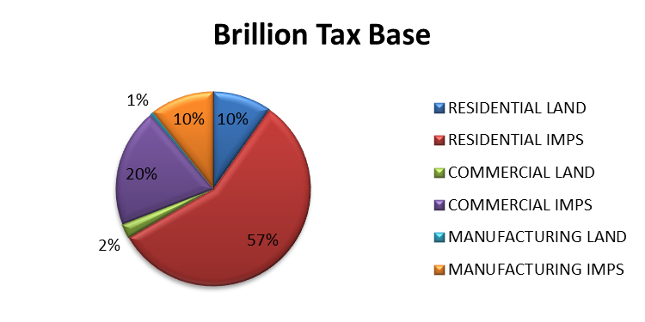

This suggests that in the currently slowed economic climate Oostburg may be in a better financial position than a municipality of similar size. The village of Oostburg is not as dependent on state shared revenues, which fluctuate and have been decreasing. Also, Oostburg is experiencing growth while Brillion appears to have remained relatively unchanged in the last twenty years. Also, Oostburg has been able to show a larger rate of increase in revenues as compared to expenditures.
Overall I believe that the Village of Oostburg is very financially stable and the preparation of the tentative budget for 2012 should be realized on time. I hope that this memorandum assists you in preparing a budget for the 2012 Fiscal Year. Please feel free to let me know if there are other statistics that you would like to consider during this process. I look forward to working with you on this in the future and will further explain the relevance of this document at the next council meeting.

