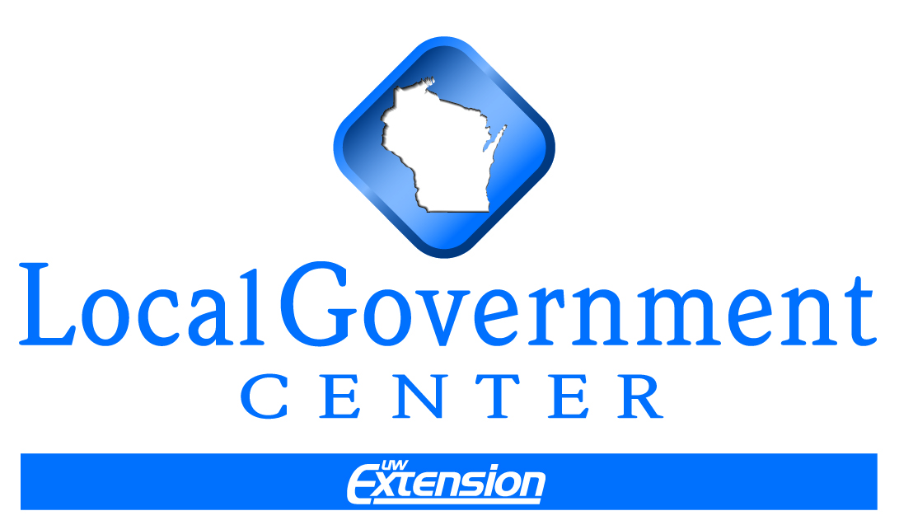

Basic Review of the Property Tax

The property tax is a major source of general revenue for local governments, which include counties, towns, cities and villages. General revenues are used to finance day-to-day operations and typically do not limit spending to certain items or activities. Taxes, some state/federal aids, intergovernmental charges, fees, penalties, and interest comprise general revenues.
In Wisconsin, the property tax is really the only tax that local governments can use in raising their general revenues. Counties can enact a .5% sales tax and along with municipalities can enact a wheel tax. Municipalities can enact a room tax, but can only retain 30% for government operations.

Property Tax Share of Revenues
The property tax, therefore, is very important to local governments. In 2008, the property tax made up about 30% of the general budget for counties, 29% for towns, 26% for villages, and 28% for cities as shown in the pie charts below. This figure would be higher if debt was not included in total revenues.

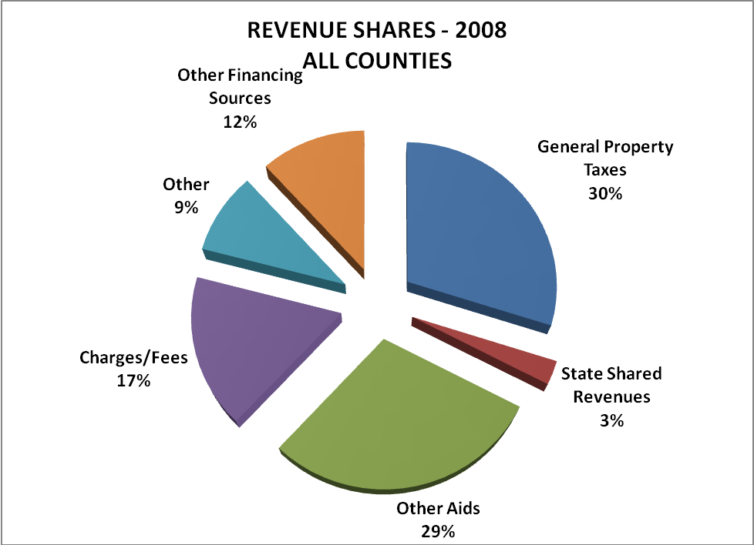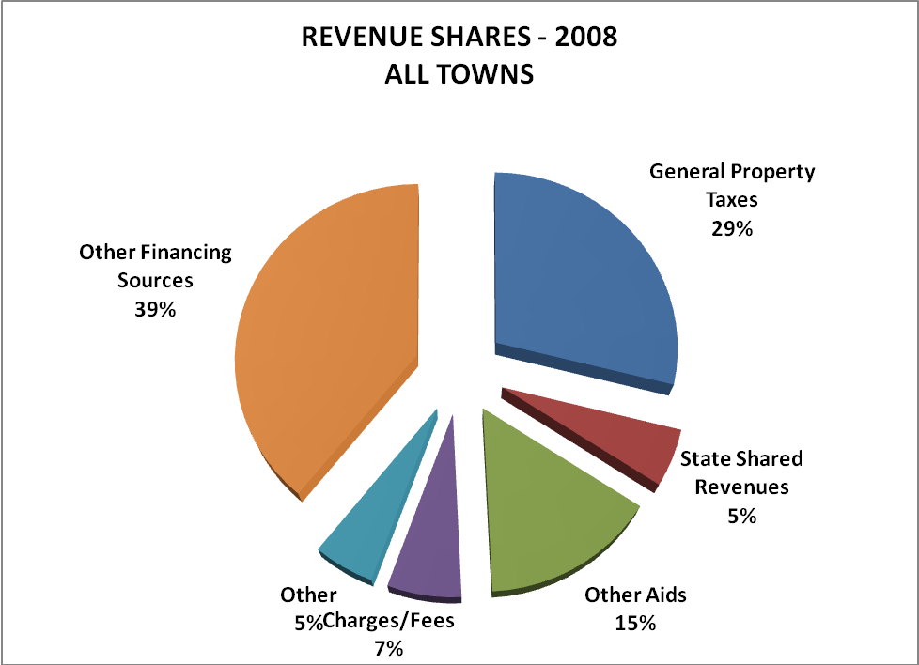
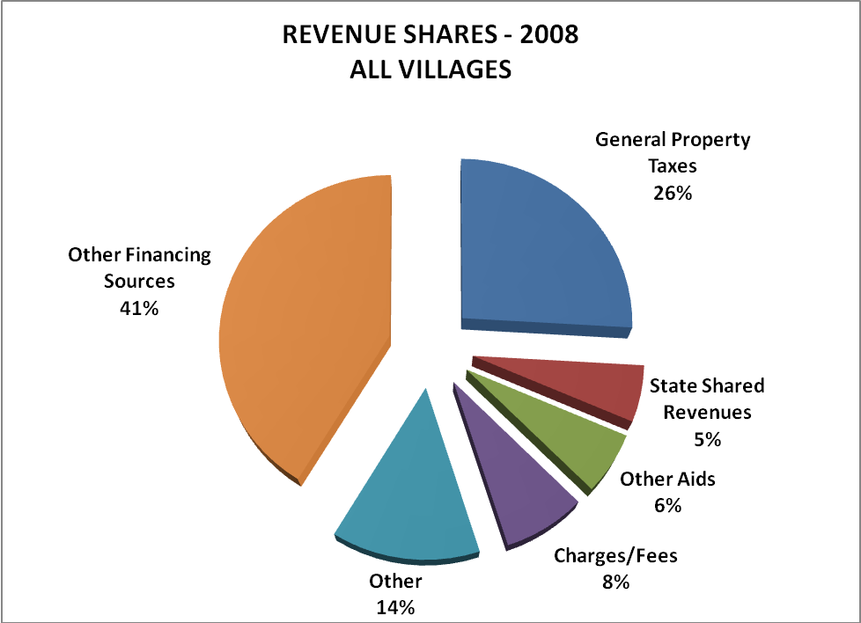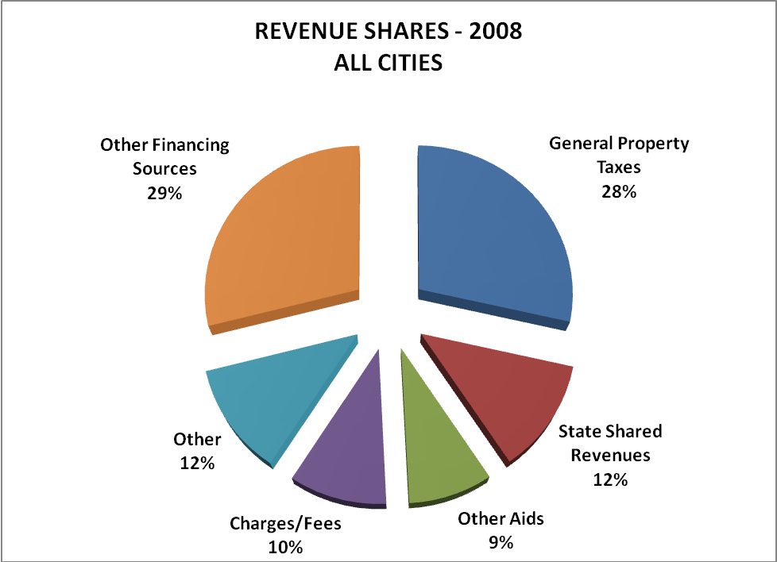

“Other financing sources” includes monies from debt and refunding debt, interfund transfers, and sales of major assets. This category makes up 39% of town revenues, 41% of village revenues and 29% of city revenues. Use of general fund transfers, sales of fixed assets, and the greater use of debt are being employed by local governments to meet their needs and to address rising costs under the property tax levy limit.

Property Tax Bill: Use and Pressure
Besides local governments, schools and technical college districts rely heavily upon the property tax for their general operations. On average, schools rely upon the property tax for 37% of their revenues and technical college districts for 44% of their revenues. The chart summarizes reliance on the property tax.
Use of Property Tax
Counties 30%
Towns 29%
Villages 26%
Cities 28%
Schools (K-12) 37%
Technical Colleges 44%

State and Local Taxes
In fact, the property tax is the largest tax in Wisconsin. Like most states, Wisconsin relies upon what are considered the “big three” taxes in financing services: property tax, income tax and sales tax. Unlike other states, however, Wisconsin has assumed central collection authority of the income and sales taxes, reserving the property tax for local governments to use and collect. The state then redistributes roughly 60% of general fund collections back to local governments and schools in the form of state aids (i.e., shared revenue, general education aids, etc.). By contrast, other states allow local governments to impose a sales and/or income tax in addition to the state sales and income tax. The table below shows Wisconsin’s state tax collections for the income and sales taxes between 1960 and 2008 and local collection of the property tax.

Property Tax Bill View: Location, Location, Location!

Depending upon where you live in Wisconsin (town, city, village), your property tax bill is going to look different. For example in towns, your “local” tax is going to be smaller with a greater portion going to the county and school districts. The average town tax made up 13% of the property tax bill in 2008 for town residents. For those same residents, the school district tax was 47%, the county tax was 28%, and the technical college tax was 10% of the property tax bill.

By contrast, the average city tax made up 33% of the tax bill for city residents in 2008. The school tax comprised another 35%, the county tax 17%, technical college tax 7%, and other taxes made up 8%. Other taxes include sanitary sewerage, lake districts, and metro sanitary districts.

What possible difference could this make? Town residents are likely to see schools and counties as “big spenders.” While city and village residents have a more even distribution among taxing jurisdictions, their local tax is likely to come under more scrutiny.

Tax Basics
There are certain basics that you examine in any tax: (1) levy or amount of tax, (2) what is taxed (base), and (3) the rate of taxation. Of course there are other considerations in tax policy, such as ability to pay and equitable application of the tax. Still, understanding these three factors will help you better understand the tax. In the case of the property tax:

- The tax base is the value of taxable property in a community. Some property is exempt from taxation.
- The tax levy is the portion of a local government’s budget that will be financed through the property tax.
- The tax rate is simply the result of the relationship between the amount needed for the property tax levy from the taxable property in the community. The rate, often called a “mill rate,” is expressed in terms of a property tax dollar amount per thousand dollars of value. Example: A property tax rate of .005 is $5 of property tax per $1000 of value. So, if my home is valued at $100,000, then my property tax would be $500 (.005 x $100,000). Or, there are 100 thousands’ in 100,000, so $5 x 100 = $500.

There are important relationships between the

Property Tax Levy = Property Tax
Property Value Rate

If property values ↑ and the levy stays the
same, the rate will ↓
If property values ↓ and the levy stays the
same, the rate will ↑

amount needed by local governments (levy), the
value of taxable property in the community (base) and the tax rate.

Increasing property values or growth in the community’s tax base with the community
levying the same amount as the prior year will
result in a decrease in the property tax rate
.
Conversely, declining property values or a reduction in the community’s tax base will increase the tax rate even if the community levies the same amount as the prior year. These relationships are not usually so simple (i.e., one component remaining the same while the other two factors change). Increases or decreases in the rate depend upon the relative increases/decreases in the property tax levy and in property values.

Property Tax Rate
Thus the rate is just a function of what is happening to the property tax base and the amount needed by local governments for their operations. So any changes to the rate will focus inquiry on what is happening to the tax base and to the levy.
Why is there such a fuss about the rate?
Property owners focus on the rate since this factor determines how much they will pay per $1000 of property value.

To begin our examination, let’s see what the property tax rates have been doing between 1990 and 2008. The graphs below show property tax rates have been decreasing for counties, towns, cities and villages. The county rate went from $5.86 in 1990 to $4.61 in 2008. The municipal tax rates show the same declining trend with towns going from $2.74 in 1990 to $2.05 in 2008; villages going from $5.24 to $4.81 in 2008, and cities going from $7.93 to $6.94 in 2008. These figures are all in 2009 dollars, thus controlling for any effects of inflation.

Tax Base
On average, property tax rates for local governments have been declining since at least 1992. What does this mean? Do local governments need less money for operations and thus lowering tax levies? Are property tax bases growing because of increasing values? Let’s look at the property tax base first. The pie charts below show how the tax base has changed statewide between 1960 and 2009.
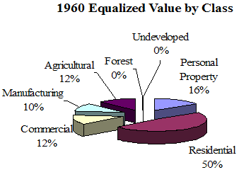
Essentially the tax base has gone from 50% residential property to 74% residential property statewide between 1960 and 2009 (includes “other" property which is farm residences and buildings). The tax base was far more
diverse in 1960 than in 2009, with commercial, manufacturing, agricultural and personal property making up relatively equal portions of the other 50%. In 2009, commercial and residential property made up 92% of the tax base. Many factors contributed to this substantial change in tax base.
Manufacturing has declined since 1960 and some tax base exemptions were enacted to boost this part of the state’s economy. There have been similar exemptions for personal property. Agricultural land, agricultural forest, and undeveloped land have reduced valuations to counter the speculative forces that increase the value of these lands beyond their productive use. Residences on average are larger, fewer people inhabit them, more people own second homes or cabins and there were significantly more houses in 2009 than in 1960.

The bar graphs below show this shift in the tax base between 1990 and 2009 for counties, towns, cities and villages. In 1990, the statewide county average for residential property was 65% of the tax base; in 2009, it was 73%.

For towns, residential property made up 69% of the tax base in 1990 and 83% in 2009. If you add in the 6.1% of “other” property (farm residences and buildings), this figure rises to 88.6% of the town tax base.

Cities on average had 61% of the tax base comprised of residential property in 1990 and 66% in 2009.

Villages showed the smallest increase of 3% in residential property between 1990 and 2009.

Property values have also increased since 1990, as shown in the graph on the next page. County values increased by 412% between 1990 and 2008. County values are a composite of the city, town and village property values. Town values increased 474% and village property values increased about 523% between 1990-2008. City property values increased 340% during this period.

Perhaps a more concrete way to see the change in property values is to look at the per capita values for local governments between 1990 and 2008. For example, county property values went from $19,257 per capita in 1990 to $94,880. These figures are shown in the table below for all local governments.

Per Capita Property Values
Local Government | 1990 | 2008
County | $19,257 | $94,880
Town | $22,236 | $113,335
City | $16,147 | $71,684
Village | $16,568 | $81,495

Differences across the state can be seen in the two maps below giving per capita equalized value for municipalities and for counties in 2008.

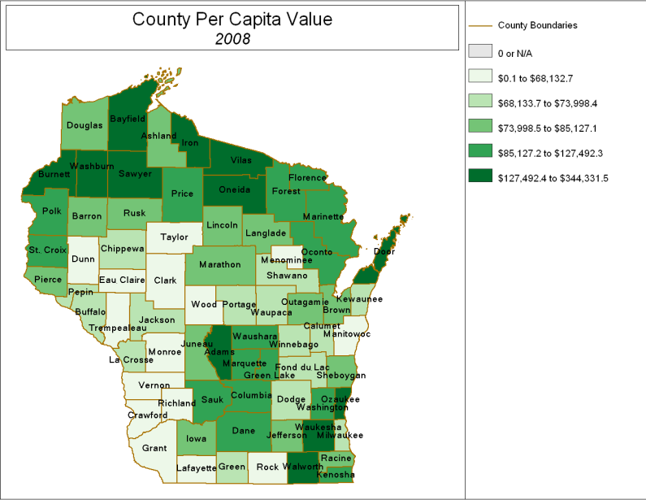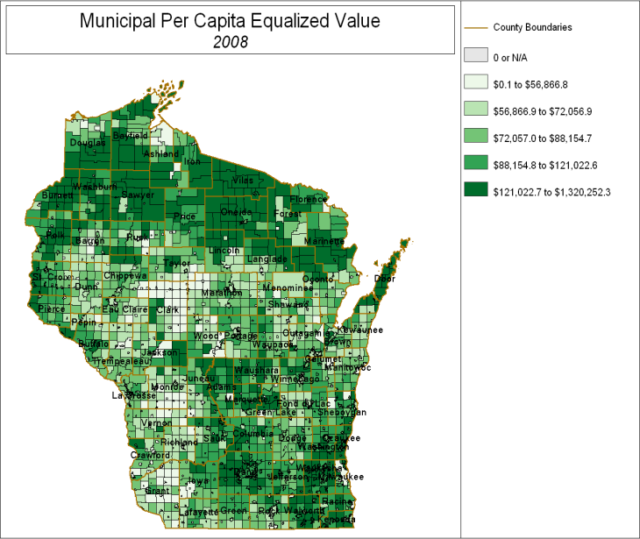
There have been shifts in the property tax base over time and property values have increased fairly significantly in the past 16-18 years. So, if property tax rates are falling and property values are increasing, what has been happening with property tax levies?

Local Property Tax Levies
The property tax is used by many jurisdictions: schools, technical colleges, counties, municipalities, state, and sometimes lake and sanitary districts. The graph below shows that the county property tax levy has increased by 274% between 1990 and 2008. Town levies increased by 318%, city levies increased by 228%, and village levies increased by 376% during this same period.

It appears that property tax levies also increased significantly during this time. The property tax rates, however, have decreased since 1990. What does this mean? In relative terms, property values increased at a higher rate than property tax levies. See the summary table below to see this in numerical terms.

% Changes in Property Tax Elements
1990-2008
Local Government | % Rate  Change | % Change in  Property Value | % Change in Tax Levy
County | -$1.25 or -21% | 412% | 274%
Town | -$0.69 or -25% | 474% | 318%
City | -$0.99 or -12.5% | 340% | 228%
Village | -$0.43 or -8% | 523% | 376%

For all local governments, the increase in property values exceeded the increase in property tax levies. For example, county property values increased 412% 1990 and 2008, but levies increased 274%. Local efforts to “increase tax base” focus on these relationships between the rate, levy and tax base (property value).

County Levy Rate Limit
Beginning in 1993, the legislature began efforts to directly curb increases in the property tax by enacting a “rate limit” on counties. Essentially, counties cannot exceed the property tax rate they had in 1992. Without getting into all of the details here, counties can increase the amount that they levy as long as property values increase. You can maintain the same rate or even lower it, if there is a greater increase in property value.

Property Tax Levy = Tax Rate
Property Value
1992 Tax Rate | 2010 Tax Rate
$8,000,000 = .006154  $1,300,000,000 | $11,077,000 = .006154  $1,800,000,000  .006154 x $500,000,000 = $3,077,000

In the example above, this county had a property tax rate of .006154 in 1992 with property value at $1.3 billion. Between 1992 and 2010, property value grew from $1.3 billion to $1.8 billion, or $500 million. Using the 1992 rate of .006154, the county could have increased its levy by $3,077,000. If this particular county had increased its levy by $2,000,000 over this period, its rate would be lower than .006154 . It would be .005555, based on:

$10,000,000__ = .005555
$1,800,000,000

If property values decline and a county is at its rate limit, then it would need to decrease its levy to maintain the rate. Suppose this particular county had a decrease in its value from $1.3 billion to $1.1 billion. The county would have to decrease its levy by $1,230,600, based on:

.006154 x $1,100,000,000 = $6,769,400 (allowable levy)
$8,000,000 - $6,769,400 = $1,230,600

Levy Limits
Both counties and municipalities have been subject to property tax levy limits beginning with 2005 levies. The allowable percentage increase has varied somewhat, but essentially local governments cannot increase their levy more than the allowable percentage or percentage change in net new construction, whichever is greater. Using the formula on the next page, this local government could only increase its property tax levy by $160,000, which is the 2% allowable increase for 2010.
Property Tax Levy = Tax Rate
Property Value
2009 Property Tax Levy | 2010 Tax Rate
$8,000,000 = .006154  $1,300,000,000 | $8,160,000 = .006277  $1,300,000,000  .02 x $8,000,000 = $160,000

Note that the property value stayed the same between 2009 and 2010. For municipalities, this would increase their property tax rate from .006154 to .006277. A county would be unable to increase its levy if .006154 was the county’s 1992 rate (rate limit). If property values declined in the example above, this county would have to decrease its levy (regardless of the allowable levy increase of 2%) until it reached its 1992 rate.

Summary
This paper explains the basic elements of the property tax and their relationship to one another, property tax usage by local and special governments, and the place of the property tax in state/local finance. The property tax is an important part of local revenues, but it is not the only component. State and federal aids make up an equally significant, if not greater, portion of local revenues. Increases in property taxes often reflect stagnant to declining revenue sources along with increased costs of providing services. Public focus on the property tax is due to its unpopularity, its high usage, and the one tax that local boards have historically been able to use to make up for revenue shortfalls and increased costs.

Resources
The Local Governance and Finance team conducted a November 2006 inservice on the property tax called Property Tax 101 and 102. The program recording, along with all program materials are available at https://www.uwex.edu/ces/apps/lgc/index.html which is under UW Extension Staff and Educator on the Local Government Center’s website at http://lgc.uwex.edu This is secured access, so you will need your username and netid to access this page.

The Legislative Fiscal Bureau develops informational papers every two years at the beginning of each budget cycle. The following papers may be of interest to you at http://www.legis.state.wi.us/lfb/Informationalpapers/info.html

Local Government Expenditure and Revenue Limits (Informational Paper 12)
Property Tax Level in Wisconsin (Informational Paper 13)
Property Tax Administration (Informational Paper 14)
Local Government Revenue Options (Informational Paper 15)
Municipal and County Finance (Informational Paper 16)
Tax Incremental Financing (Informational Paper 17)
Shared Revenue Program (County and Municipal Aid and Utility Aid) (Informational Paper 18)
Targeted Municipal Aid Programs (Expenditure Restraint and Computer Aid) (Informational Paper 19)
Payments for Municipal Services Program (Informational Paper 20)
State Property Tax Credits (School Levy, First Dollar, and Lottery and Gaming Credits) (Informational Paper 21)
Property Tax Deferral Loan Program (Informational Paper 26)

The Department of Revenue has a number of publications and reports that involve the property tax:

Town, City and Village Taxes at http://www.dor.state.wi.us/pubs/slf/tvc09.pdf Note that this data is in the GREAT software.

Net New Construction Report at http://www.dor.state.wi.us/equ/nnc.html Note this is updated each year.
Statement of Changes in Equalized Values at http://www.dor.state.wi.us/equ/report2.html Note this is updated each year and provideshistorical information by category of property, and percentage changes due to new construction and to property value growth/decline for every county and municipality. This data is also in the GREAT software.
Wisconsin State and Local Taxes FY 87 – FY2006 at http://www.dor.state.wi.us/ra/07taxwi.pdf
A Property Tax Guide for Mobile Home Owners (2/08)
Agricultural Assessment Guide for Wisconsin Property Owners (1/10)
Government Program and Eligibility for Use-Value Assessment
Guide for Board of Review Members (1/10) -- See the Board of Review FAQs
Guide for Property Owners (4/10)
Guide to the Property Assessment Process for Wisconsin Municipal Officials (12/04)
Property Assessment Appeal Guide For Wisconsin Real Property Owners (4/10)

There is also a Frequently Asked Questions Page on the Department of Revenue Website:

Ag Forest & Undeveloped Land
- Qualifying Parcels
- Ownership
- Roads and Similar Issues
- Valuation of Agricultural Forest and Undeveloped Land
- Undeveloped Land
- Miscellaneous

Board of Review
- Filing Objections/Forms
- Scheduling Objections
- Hearings/Proceedings
- Removal of Members
- Decisions

Other
- First Dollar Credit
  - Sample Property Tax Bill
  - How to Calculate the First Dollar Credit
  - First Dollar Credit and Related FAQs
- Levy Limits
- Lottery and Gaming Credit
- Manufacturing Assessments
- Property Assessments in a Declining Market
- Real Estate Transfer and Merger/Conversion
- Tax Incremental Financing
  - Frequently Asked Questions
- Telecommunications Property Tax
- Use-Value Assessment
- Use-Value Conversion Charge
- Waste Treatment Exemption

Finally, the Executive Budget and Finance Office in the Department of Administration each year puts out a number of reports, including the annual fiscal report. This report provides basic summary information on state taxes and expenditures.

State Fiscal Year Ended June 30, 2009 (PDF)
Appendix to 2009 Report (PDF)

