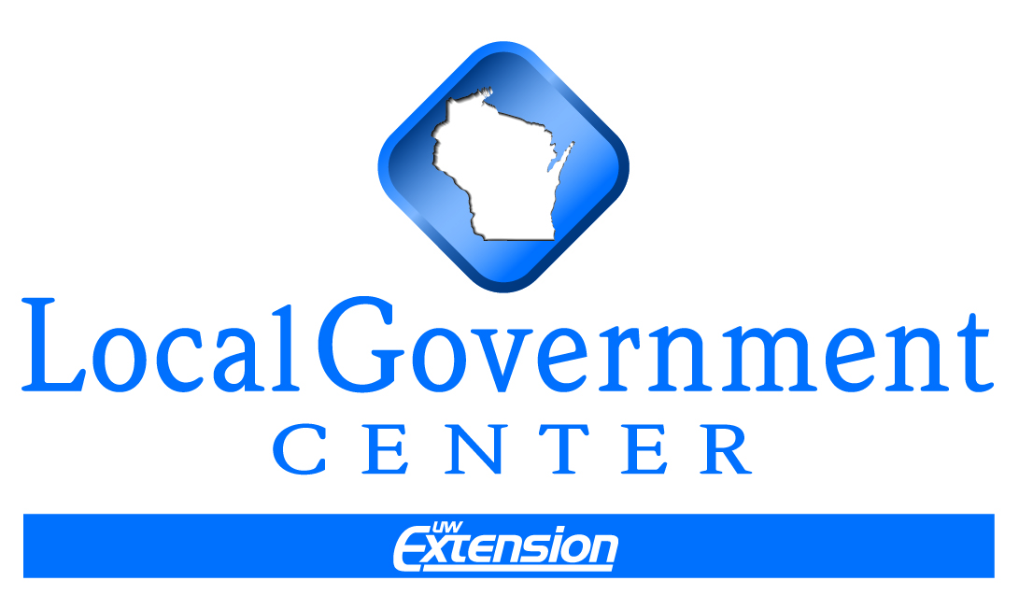
ANNUAL COUNTY BUDGET
2012 County Official Workshops
By Kate Lawton

Current law requires every county to prepare an annual budget under s. 65.90, Wis. Stats. The annual budget is a county’s fiscal and program plan for the next year based on estimates of revenue, costs and demand. While the budget is a short-term plan, it is the result of the county’s long-term plans and a primary implementation tool of them. Based on the statutory procedures for budget review, adoption and amendment, the annual budget is also local legislation. Relevant statutes are listed in the end notes.

Budget Development
The process of budget development varies from county to county as does the responsibility for managing the process. For example, a county administrator is responsible for managing the development of the budget and submitting it to the county board under the law. The county administrator works directly with department heads, oversight committees and the finance committee in managing the budget process for the board. In counties with an executive, the executive develops and submits the budget to the county board and has line item veto authority over the budget adopted by the county board. Items vetoed by the county executive can be overridden by a two-thirds vote of the county board. In a number of counties, the clerk or another department head is designated as the “administrative coordinator” and is assigned responsibilities for managing the budget process. The October 2011 Attorney General Opinion 01-11 stated that counties could not designate the county board chair or another supervisor as the coordinator as it violates s. 66.0501(2) which prohibits elected officials from serving as employees for positions that the board has authority to select. See Appendix A for sample budget processes under these three administrative structures. There are other important roles that shape a county’s budget process.

County Supervisor Roles: Committee and Board Member
County supervisors wear two hats. The first hat is that of a member of departmental oversight committees. Members become very knowledgeable about specific departments and their programs in this role. Committee members review programs and recommend policies to the entire county board. The more information committee members have, the more they are able to suggest alternatives, evaluate revenue sources, recommend program changes and support the department with the full county board.

The other hat worn reflects the responsibilities of being a supervisor that represents the entire county. Each supervisor must vote on an overall county budget that balances program needs across all departments with available county resources. The ability of county supervisors to wear these two hats simultaneously plays an important role in achieving a thoughtful and balanced county budget. To do this effectively, they need the expertise of the department heads in conjunction with the big picture view of the budget coordinator.

Department Heads
Heads of departments provide their oversight committees with program information, alternative budget scenarios, options, innovations and best practices. They bring expertise and experience to the budget process as well as their management skills.

The process that follows is only descriptive and highlights basic components of the budget process. The discussion includes a budget coordinator that is a separate position from the county board chair or clerk. Request a review of your county's budget process as part of your orientation.

Initial revenues and expenditures are estimated.

One way of viewing a budget is as a descriptive document depicting the amount of different monies coming in and how they will be spent. In order for the board to develop reasonable fiscal guidelines, the board must have an idea of the how much money will be available and the expected cost and level of services. Initial revenue and expenditure estimates are therefore developed and amended throughout the budget process.

Revenue Estimates
It is helpful to understand the major sources of general revenues for counties. The chart below shows the percentage of major county revenues for three selected years over a 21-year period: 1987, 1997, and 2009. Property taxes make up roughly 30% of county revenues between 1987 and 2009. On the other hand, intergovernmental aid is about 42% of county revenues in 1987 and 28.6% in 2009. Of this amount, shared revenue goes from 8.3% of county revenues in 1987 to 2.6% in 2009. Overall, intergovernmental aid makes up 13% less of county general revenues in 2009. Intergovernmental charges and public fees for service increase from 9.8% of revenues in 1987 to 15.1% in 2009. Other revenues, which include the county sales tax, increases as a percent of revenues from 6.4% in 1987 to 7.9% in 2009. Sources of other financing include long-term debt, refunding bonds, interfund transfers and sale of major assets. This revenue source increased from 11% to nearly 19% of revenues.

There are basically four revenue components that the budget coordinator estimates for the proposed budget year: non-property tax revenues, fund balance, special tax levies, and the property tax levy.

Non-Property Tax Revenues
The budget coordinator estimates how much revenue will be received from sources outside of the property tax levy. These major sources of revenue for this category include:

- Intergovernmental aids (shared revenue, transportation aids, social service allocations)
- County sales tax
- Licenses, permits, and fees
- Penalties and fines
- Public charges for services
- Intergovernmental charges for service
- Interest income
- Debt principal

The Department of Revenue notifies each county on September 15 of the estimated amount of shared revenue payment it is expected to receive in the coming year. The Department of Transportation notifies each county on October 1 of the estimated amount of general transportation aids it is are expected to receive in the coming year.

Fund Balance
The budget coordinator estimates the amount of the year-end available fund balance. This estimate is calculated by adding the current year’s beginning fund balance with current year estimated revenues. From this amount, the coordinator subtracts estimated current year expenditures and estimated expenditures from reserves. The reason the revenues and expenditures must be estimated is that the board is developing the budget before the year is complete – before all revenues have been collected and all expenditures have been made. The calculation is shown below.

Beginning Year Fund Balance

+ Estimated Current Year Revenues

- Estimated Current Year Expenditures

- Estimated Expenditures from Reserves

= Year-End Available Fund Balance

From the year-end balance, the county board decides how much of the available balance will continue into next year’s revenue mix. Surpluses in the available year-end fund balance can be used for many purposes, some which include: reducing the tax levy, paying off debt, increasing reserves, and purchasing capital items. The board should direct the use of a surplus as soon as possible in the budget process. A note of caution, however, is in order here. Use of a one-time surplus to finance an ongoing expense or to reduce the property tax levy may require a higher increase in the property tax or other revenue source in the future than otherwise would occur, especially in years that are fiscally strained. Often counties use one-time surpluses on infrequent capital purchases, debt retirement, or to increase reserves to avoid this effect.

Special Property Tax Levies
Counties have authority under the law to levy a tax on municipalities in the county that benefit from projects and services such as highway bridges, the county handicapped children’s educational board, libraries, public health, and solid waste or recycling. The costs for these must be calculated and then allocated across participating municipalities. These special levies are excluded from the county’s operational budget for purposes of calculating the tax levy rate limit, but not all of them are for the property tax levy limit.

Allowable Property Tax Levy
The state has regulated how much counties and municipalities can raise through the property tax by limiting “levy” increases to a certain percentage or the percentage change in net new construction, whichever is greater,
since 2005. The allowable percentage increase has shifted from year to year, as have the allowable adjustments. For 2011 and 2012, the allowable percentage increase is 0% and this has no sunset date. However, the law allows that counties that did not use their full percentage increase from the prior year could use up to .5% of it as a levy increase. Those counties that opted to do so had to reduce their levy by any debt expense for debts paid off that were incurred prior to July 1, 2005, unless they assumed an equal amount of new debt expense. Those counties not opting to use .5% of carryover did not have to make any such adjustment.

Counties are also subject to a county levy “rate” limit, which is the greater of their 1992 levy rate or .001 mills. For the 2011 and 2012 levies, this rate limit has been suspended. Had there not been a suspension, several counties would have had to decrease their property tax levy in 2011 due to declines in property values. See the endnotes for a more detailed discussion of the property tax rate limit.

Thus counties must calculate all of their revenue sources and only use the property tax to the extent that it is allowed under the law. The calculation below shows a summary of the revenue estimates that must be made for a county board to establish budget guidelines.

Non-Property Tax Revenues

+ Year-End Fund Balance

+ Special Tax Levies

+ Property Tax Levy

= Total Estimated Revenues

Decreases in major revenue sources, such as state aids or the county sales tax, may be made up in several ways. Some basic ways to meet revenue shortfalls include, but are not limited to:

- Increase other revenue sources such as public fees and intergovernmental charges for services.
- Decrease expenditures and reserves.
- Spread capital projects out over a longer timeline.
- Become more cost effective by using different service delivery options, hiring an administrator, changing vendors, and so forth.
- Examine the balance between the operating and capital budgets.
- Lobby the legislature for greater tax authority and flexibility in meeting state requirements.

Whatever adjustments are made, the expected degree and duration of the decreased revenue will help guide the board in designing fiscal strategies to meet the challenge. One way to see the effect of proposals to reduce state aid to local governments is to follow the analyses of the Legislative Fiscal Bureau (www.legis.state.wi.us/lfb/) under their “publications” section.

Expenditure Estimates
It is helpful to understand major categories of expenditures for counties, which are shown as a percentage of general expenditures in the bar chart on the following page for 1987, 1997 and 2009. County protective service expenditures increased 3.8% as a percent of expenditures between 1987 and 2009 and county government administration expenditures increased 4.2% as a proportion of the budget during this period. County highway expenditures decreased 2.4% as a percentage of general expenditures between 1987 and 2009, but this may reflect changes in financing from general revenues to proprietary funds. Expenditures for conservation, culture, and parks have decreased by about 3% as a percentage of expenditures. There was also a decrease in other expenditures as a percent of general expenditures by about 1% between 1987 and 2009, which includes interfund transfers, refunds and contributions.

In estimating expenditures for county budgets, the coordinator will look at large county costs and their probable increase in the coming year. Examples include wages, healthcare, other insurance coverage, energy, overtime, construction, and large capital outlays. Other factors that are included in estimates are state and federal law changes that may affect cost or increase service demand, recent weather disasters requiring emergency outlays, and economic and demographic changes that increase service demand.

Board establishes fiscal and policy guidelines.

The county finance committee is usually responsible for recommending financial policies and guidelines to the county board for approval. Guidelines should be established as soon as possible to assist departments in their decision-making and budget requests. Examples of fiscal guidelines include, but are not limited to:

- Wage increases.
- Employee benefit costs.
- Levels for reserve funds, such as contingency, nondesignated and capital reserve funds. These should be consistent with the capital improvement plan and the debt management plan.
- Priorities in capital improvement projects and allowable expenditures.
- Level of fee increases, intergovernmental charges for service, and other program revenues.
- Levels of service, elimination of services, or changes in service delivery such as transfer of services to other governments/private sector/nonprofits, contract for service, or consolidation of services.
- Tax policies, such as enacting the sales tax, use of special property taxes, and any further limitations on the use of the property tax.

These fiscal and policy guidelines are not developed in a vacuum. Based on the county’s strategic plan and related plans (i.e., comprehensive growth plan, capital plan), the county board should determine its goals and needs within its fiscal limitations for the coming year. Part of this review may include program evaluations and work plans for departments and programs. Evaluations can also include recommendations from the financial and/or performance audits that call for investments in a new computer system, increased staffing, etc. See Appendix B for a brief explanation of government audits and Appendix C for a review of the capital planning process.

Budget coordinator prepares budget calendar.

The budget coordinator prepares a calendar that lays out a timeline for the budget process, assigning duties and noting persons responsible. This task establishes a reasonable timeline of duties to ensure that none are overlooked, a logical sequence of events, and a record of who is responsible for what and when. The county board, or the finance committee, should review and approve the calendar, as the board is ultimately responsible for the budget. Counties can establish their budget calendar by working back from a desired date for budget adoption, such as the annual meeting in November. A sample calendar may look like this:

Responsibilities | Dates
Mid June | Board provides fiscal guidelines
Mid July | Coordinator and departments prepare budget requests
August | Departments and Coordinator review requests with committees
2nd Week of September | Coordinator compiles department budgets approved by committee
End of September | Finance committee reviews  budget requests/makes changes
Early October | Finance committee presents  budget to county board for  review and any changes
Late October | County board conducts public  hearing on budget
On Tuesday after the Second Monday in November | County board adopts budget  at annual meeting

Departments prepare expenditure requests with budget coordinator within fiscal guidelines and review requests with their committees.

County departments work with the budget coordinator within fiscal guidelines to develop their budget requests. The requests will include salaries, benefits, overtime, supplies, training, insurance, and other operating expenditures as well as capital expenditures. These may be broken down by program with a summary justifying the request, and may include a work plan and objectives for the coming year. Depending upon the budget process in each county, the information requested of departments can include: a description of the program, its purposes, the county’s goals, the past year accomplishments, areas of need and concern, recommendations to resolve problems, a work plan, and objectives that can be measured and evaluated throughout the year. The coordinator and department heads will initially make their requests to their respective standing committee for approval. The department heads bring expertise and information to this part of the process while the budget coordinator answers questions about the larger budget picture.

The oversight committee can make changes to the department request prior to submission to the finance committee. Changes may result from such factors as difficult policy choices, revised revenue estimates, actual or anticipated state law changes, program evaluations, or anticipated changes in service demand.

The budget coordinator compiles the department budgets approved by the standing committees for review by the finance committee.

The finance committee reviews the draft budget drawn together by the budget coordinator. The coordinator and respective department heads may give presentations to the finance committee and answer questions. Members of the relevant oversight committees may also explain their decisions before the finance committee. Questions may pertain to the effects of program reductions, alternative revenue sources, or the effects of delaying capital expenditures.

The role of the finance committee is to fashion a balanced budget that best meets the needs and goals of the county while staying within the board’s fiscal and policy guidelines. The finance committee may make several changes to the budget while balancing budget priorities. Once this step is complete, the committee approves a draft budget for review and action by the full county board.

The county board reviews the draft budget recommended by the finance committee.

At this point in the process, the full county board has the opportunity to review the entire budget recommended by the finance committee. The budget coordinator and a member(s) of the finance committee make a presentation explaining the draft budget to the county board. Supervisors get their first opportunity to review the budget in total and must determine whether the priorities in the draft budget are balanced and acceptable. As members of oversight committees, they can lobby other supervisors to support changes they would like to see on behalf of their departments. Changes to the draft budget may result from these successful lobbying efforts or other factors, such as revised revenue estimates, pending law changes, economic conditions and so forth. Once this process is completed, and any changes are made, the board approves a proposed budget for public hearing.

Public Review, Board Adoption and Amendment

The board holds a public hearing on the proposed budget.

Notice with Budget Summary
The clerk must publish a Class I notice for the public budget hearing. The notice must state where the detailed budget may be inspected by the public and the hours available for doing so.

The notice must also contain a budget summary, a sample of which is shown on pages 9 and 10. Under state law, the budget summary must include the following information: (1) all general fund revenues and expenditures for the current and budget year using accounting categories under the governmental chart of accounts, (2) the percentage changes between the current and budget year for the property tax and total revenues and expenditures, (3) beginning and year-end general and proprietary fund balances, (5) total revenues and expenditures by governmental and proprietary fund type, indicating the contribution of the property tax to the fund, and (6) increases and decreases to the budget due to new or discontinued activities transferred between local governments. Counties may include further information they deem appropriate in the budget summary beyond the statutory requirements. In the sample notice shown on pages 11 and 12, Badger County includes information on the county’s special tax levy for libraries as well as a number of explanatory footnotes. It is also not uncommon to include the past year’s actual revenues and expenditures for the general fund as a basis of comparison. The reason for this addition is that the past year contains actual figures while the current year is made up of actual and estimated revenues and expenditures. Budget year figures are based solely upon estimates.

Public Hearing
The county board holds a public hearing on the budget at least 15 days after the Class I notice is published. Besides providing the public with a budget summary as part of the notice, the board may have the budget coordinator give an overview of the budget before taking public comments. This may be especially helpful when there are contentious issues or difficult decisions have been made in balancing priorities. In addition, an overview of the budget allows the public to better understand the board’s decisions and will help them in their comments.

(Narrative continues on page 11)

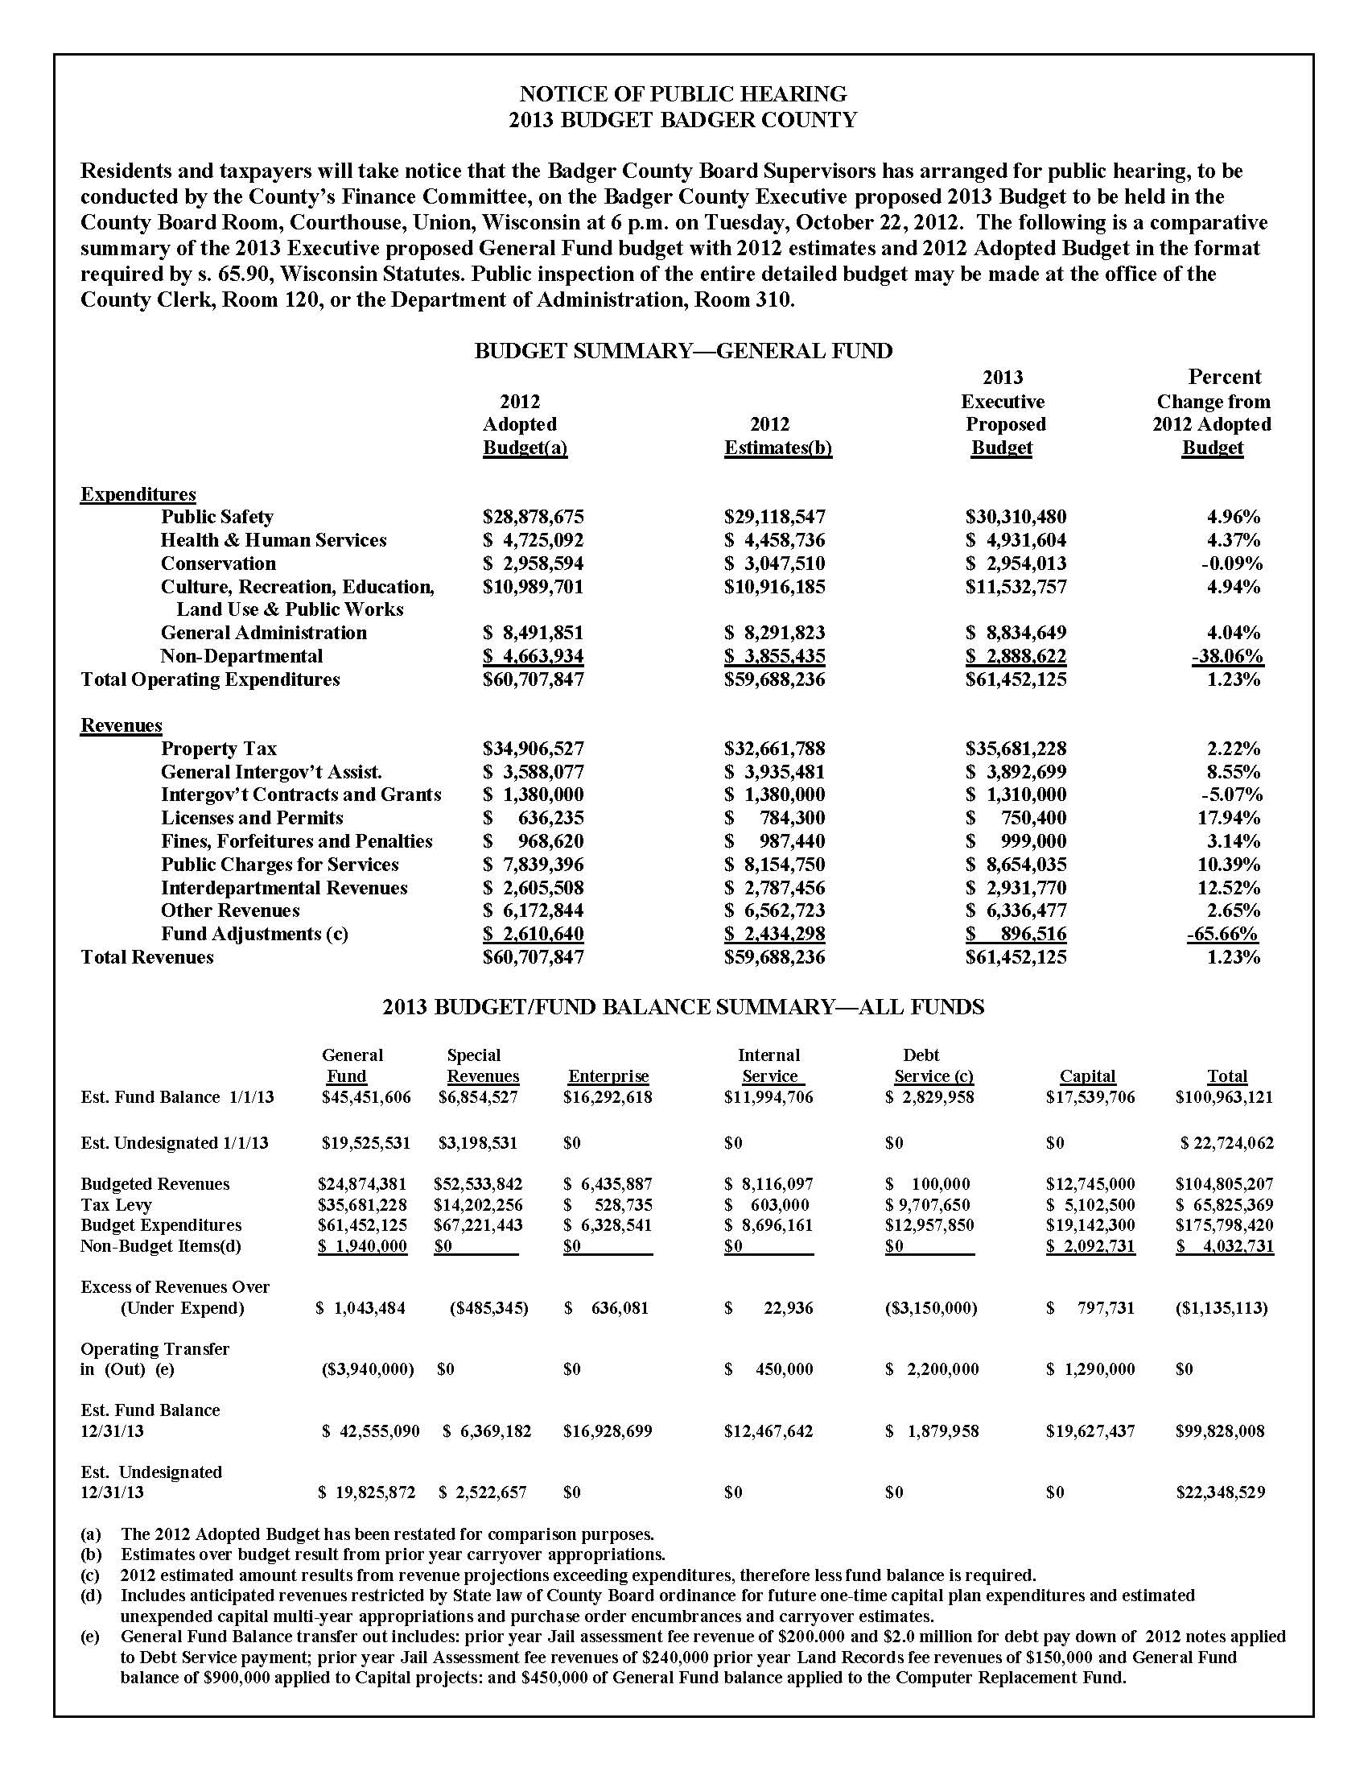
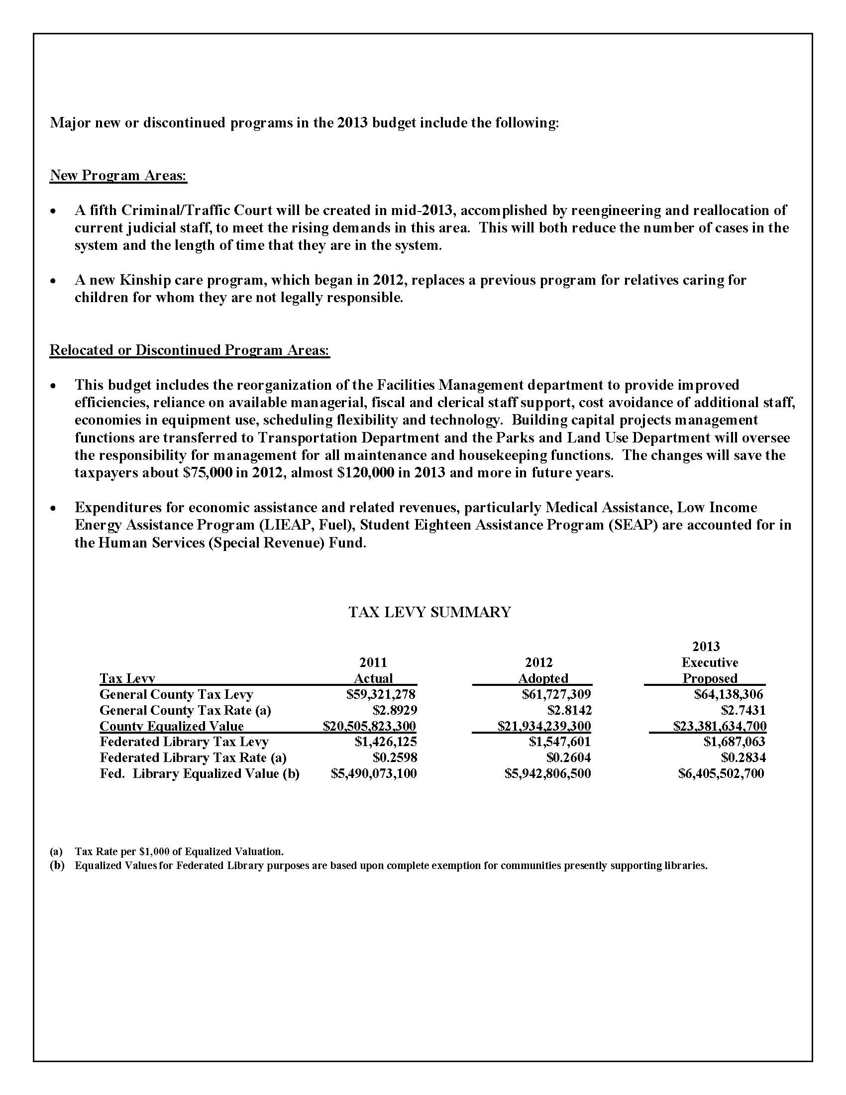

The board adopts a budget after the public hearing.

Based on public comment, the board may make changes to the budget or may just adopt the proposed budget. The public hearing notice may include a notice of a county board meeting following the hearing to discuss budget changes and to adopt the budget. The county board must adopt the budget before the end of the year and preferably before early December, when the mill rate worksheets are submitted by other taxing jurisdictions to the county.

Once the board adopts a budget it becomes law. While the budget itself requires only a simple majority vote, future amendments to it require a two-thirds vote by the board for passage. The board can delegate some of its amendment authority to the finance committee. Specifically, the finance committee can be given the authority to transfer up to 10% of an entire department appropriation within the department as well as approve transfers from the contingency fund. An amendment to the budget includes, among other actions, transfers of funds between departments and unexpected increases in revenues (borrowing money). The board should give careful thought to the budget document it adopts to minimize amendments but still maintain oversight. A budget document that lists every item will require frequent amendments, at least by the finance committee. By contrast, a budget document that is too general cuts the board out of making important budget decisions that would balance competing program needs.

Monitor and amend the adopted budget.

The budget coordinator should prepare monthly, or at a minimum quarterly, financial reports that summarize actual revenues and expenditures against budgeted figures. The finance committee and board review the reports to determine if any budget amendments are required. In counties where the authority is delegated to the finance committee to transfer appropriations within a department or from a contingency reserve fund, those changes can be made without approval of the county board. Transfers from the contingency reserve fund, however, must be followed by a Class I notice, within 10 days of the amendment, to be valid. For all other transfers of appropriations, the amendment requires approval by two-thirds of the county board. These, too, must be followed by a Class I notice within 10 days of the amendment. The coordinator records all amendments to the budget in the budget document, and any appropriate worksheets, and these amendments are reflected in future financial reports to the board.

Conclusion – Support the Budget as a Key Policy Implementation Document
This paper reviewed the statutory requirements of county budgets and highlighted points in budget development, adoption and amendment. Much was left unsaid about what supports this important annual process in the county. After all, the budget is a county’s annual fiscal and program plan. What might better support this process in your county?

Multi-Year Budgeting
Although the budget is an annual process and document, many counties have adopted a multi-year budget that forecasts revenues and expenditures for the next two to three years. This helps counties adopt longer-term revenue and expenditure strategies that are in line with their plans and economic conditions.

Planning
A budget should reflect a county’s strategic plan, which contains a county board’s long-term vision and goals informed by other plans, the public and collaborating communities. When the budget process is substituted for a county’s strategic planning process, the plan is incremental at best, short-lived and often reactive. Other plans that inform the county budget are the comprehensive plan, with its infrastructure estimates and various implementation strategies, and the capital improvement plan. The capital plan is often for a period of 5-10 years, inventories all current and future capital items, prioritizes and schedules purchases and repairs, and indicates the revenue sources of purchases.

Technology and Financial Policies
Other systems and policies also support and inform the budget process. For example, a county may regularly upgrade its automation system to support payroll, billing, collections, accounting, book-keeping, monitoring and reporting. Related financial policies that support the budget process include, but are not limited to, those pertaining to fees, investments, reserves, and borrowing practices.

Information and Reporting
Good information and effort upfront in the budget process help reduce the need for later changes and potential conflicts among competing interests. Program and budget reports throughout the year keep the board and the public apprized of changes, budget reallocations, and successful outcomes. County boards may require department heads to provide regular updates on programs and work plans, annual program evaluations, and budget requests that require a listing of alternative program scenarios that afford different levels of county support and various service delivery options. As a part of this, the county board may want to look at developing an audit plan of key programs and county functions.

Balancing Roles
A substantial challenge for many county boards is the reality that supervisors wear two hats – as both members of the county board and as members of standing committees. Some county boards have experienced difficulties because supervisors have been unable to balance their roles as a board member and a committee member with the result that the committee system fragments the board. In such situations, committees advance their agenda and support of departments to the county board without acknowledging the legitimacy of other committees’ needs. In some ways, it is perfectly understandable. Committee members learn a great deal about the departments and programs they oversee and the need for the departments’ services. But the greater awareness of committee members about certain areas of county government must be balanced against their lesser knowledge of other areas and a willingness to learn from their fellow supervisors. This lack of effective communication and decision-making becomes even more stressed during tight fiscal times. When interests across areas need to be balanced in the larger budget, a county’s strategic plan provides a larger framework for the county board to balance priorities. However, there may be a larger need for education on communication, negotiation, effective meetings, and public policy decision-making.

Policy-Making vs. Management
Supervisors can be greatly assisted in their policy-making roles by their department heads and the budget coordinator (or administrator and executive). Department heads provide expertise, extensive background information, and the ability to develop alternative implementation scenarios. In fact, an essential ingredient to the success of the entire budget process is maintaining the distinct roles each plays – county board supervisors make policies and oversee departments; county department heads and the coordinator manage the functions that make those policies a reality. Confusing these roles easily leads to conflict and neither role, policy-making nor management, is performed well.

The budget will integrate and reflect all that a county provides its citizens, and thus budget development, monitoring and amendment should be supported by effective financial policies, plans and procedures. One thing is certain – budgeting is an ongoing process and never really ends. So, why not use it to the fullest extent possible?

Assistance in developing this paper was provided by the Bureau of Local Financial Assistance at the Department of Revenue, which included providing the sample budget hearing notice and summary. The discussion of the county tax levy rate limit is in part based on Informational Paper #12, “Local Government Expenditure and Revenue Limits,” by the Legislative Fiscal Bureau.

kml
updated 5/11/2012

End Notes
Relevant Statutes

65.90 This statute sets out the process and documentation requirements for budget review, adoption and modification. Other relevant sections of the statutes are:

59.605 This statute limits the county's operations budget levy rate to .001 or the 1992 operational levy rate and
debt levy rate, and provides for the conditions and procedures to increase these rates. Penalties are listed for
noncomplying counties. Also, this section limits the debt levy rate to the 1992 level.

66.0602 This statute imposes a tax levy limit on counties and municipalities equal to the percentage change in net
new construction or 0%, whichever is greater.

Art. XI (2) This article of the Wisconsin Constitution limits the debt a county can incur no more than 5% of equalized value.

Budget Process Requirements
Section 65.90 requires any jurisdiction with the power to levy a general property tax to prepare an annual budget. The basic statutory requirements for counties are:

(1) Publish a Class I notice of the budget hearing, including a summary of the budget.
(2) Not less than 15 days after the posted hearing notice, the county board must hold a public hearing on the budget.
(3) Hold a county board meeting to adopt the budget by simple majority.
(4) A two-thirds vote of the county board is required to amend the adopted budget. The county must post a Class I
notice for approved budget amendments within 10 days of their approval. A county board may authorize its
finance committee to transfer funds between budgeted items within a county department or office up to 10% of
the department appropriation, and to make transfers from the contingency fund. Transfers from the contingency
fund are subject to the Class I notice requirements applicable to amendments.

Budget Document Requirements
Section 65.90 also specifies documentation requirements for the budget hearing notice and the budget summary:

(1) The hearing notice for the proposed budget must indicate where the budget in detail is available for public review.

(2) The budget summary must include all revenues by specified category (taxes, special assessments,
intergovernmental revenues, licenses and permits, fines, forfeitures and penalties, public charges for
services, intergovernmental charges, miscellaneous revenues, and other financing sources) and all expenditures by specified category (general government, public safety, public works, health and human services, culture, recreation and education, conservation and development, debt service and other financing uses).

These figures must be for the current year and the budget year and indicate percentage changes between these years. The budget summary must note proposed increases and decreases to the current year budget due to new or discontinued activities and functions.

The budget summary must contain all beginning and year-end governmental and proprietary fund balances, indicating the contribution of the property tax to each fund. The fund balances must show revenue and expenditure totals by fund.

Property Tax Levy Rate Limit

Counties are subject to a tax levy “rate” limit, which has been suspended for 2011 and 2012. On August 15 of each year, the Department of Revenue notifies each county of its equalized property value. This value, less any TIF increment, is used to determine the operating property tax levy rate limit, which cannot under law exceed the 1992 rate or be more than .001 mills, whichever is greater.

Each county's total tax levy and rate are separated into two components for the purpose of determining the tax levy rate limits: operation and debt. The debt levy is made up of debt service for long-term promissory notes, general obligation bonds and state trust fund loans. The operating levy is for all expenses other than debt, but excludes projects and expenses that are associated with special taxes that are not levied over the entire county: bridge aids, libraries, county handicapped children's educational board, sanitation, solid waste or recycling, and public health.

Operating Levy = Operating Levy Rate
Equalized Value (Less TIF)

1992 Operating Tax Levy Rate | 2012 Operating Tax Levy Rate
$8,000,000 = .006154  $1,300,000,000 | $11,077,000 = .006154  $1,800,000,000  .006154 x $500,000,000 = $3,077,000

The calculations above give a quick overview of how these levy rates are determined. Based on this formula, counties can increase their operating levy without a referendum if their equalized valuation increases. However, they can only increase their operational levy up to the point where the “operating levy rate” is equal to the 1992 rate or .001 mills, whichever is greater. In the example above, the county could have increased its operating tax levy by $3,077,000 based on a $500 million increase in equalized value between 1992 and 2012. Similarly, if equalized values declined, so would the amount that could be raised through the property tax. Note that the operating levy rate limit is the same in the calculation for the 1992 and the 2012 levies, .006154, or roughly $6.15 per $1000 of value.

The maximum operating tax levy rate limit can be changed in two ways under current law. First, the Department of Revenue adjusts the rate automatically when a county assumes services from or transfers services to other local governments. Services that the county assumes from other local governments will result in an adjusted increase to be determined by the Department; services the county transfers to other governments will result in a decrease to the 1992 operational levy rate. An example of a county assuming a service from municipal governments would be the establishment of a countywide park system from existing municipal parks. Counties can also increase their operational tax levy, or rate, if approved by referendum without penalty. The referendum can specify the increase for a certain period of time or indefinitely.

The debt tax levy rate limit is calculated in a similar way. However, statutory limitations on the debt levy rate are not as restrictive. The debt levy rate can be changed if one of the following conditions is met:

(1) The debt is approved through referendum if it would cause the county's debt levy rate to exceed the 1992 rate.
(2) The debt would not cause the debt levy rate to exceed the 1992 rate based on the reasonable expectation of the
county board.
(3) The debt was authorized prior to August 12, 1993.
(4) The debt would be used to abolish grade crossings or for regional projects.
(5) The debt would be used to refund existing debt.
(6) The debt is authorized by a 75% vote of the county board.

The county clerk must report the current year's tax operating and debt levies and rates, which are payable in the following year, to the Department of Revenue by December 15 each year. If a county exceeds its levy rate limit, the Department will penalize the county dollar for dollar by the amount it exceeded the limit by reducing its shared revenue payment. If the amount exceeding the 1992 levy rate is greater than the shared revenue payment, the Department of Transportation will reduce the county's general transportation aid payment by the remaining amount.

Application of “Levy Rate” Limit and “Levy” Limit
For counties, both the levy rate limit law and the levy limit law apply with the more restrictive limit ruling.

