Financial Goal Setting

Rate your comfort level in each of these financial areas with 0 being low and in the middle of the circle and 10 being high and at the outside of the circle.

Savings
Debt
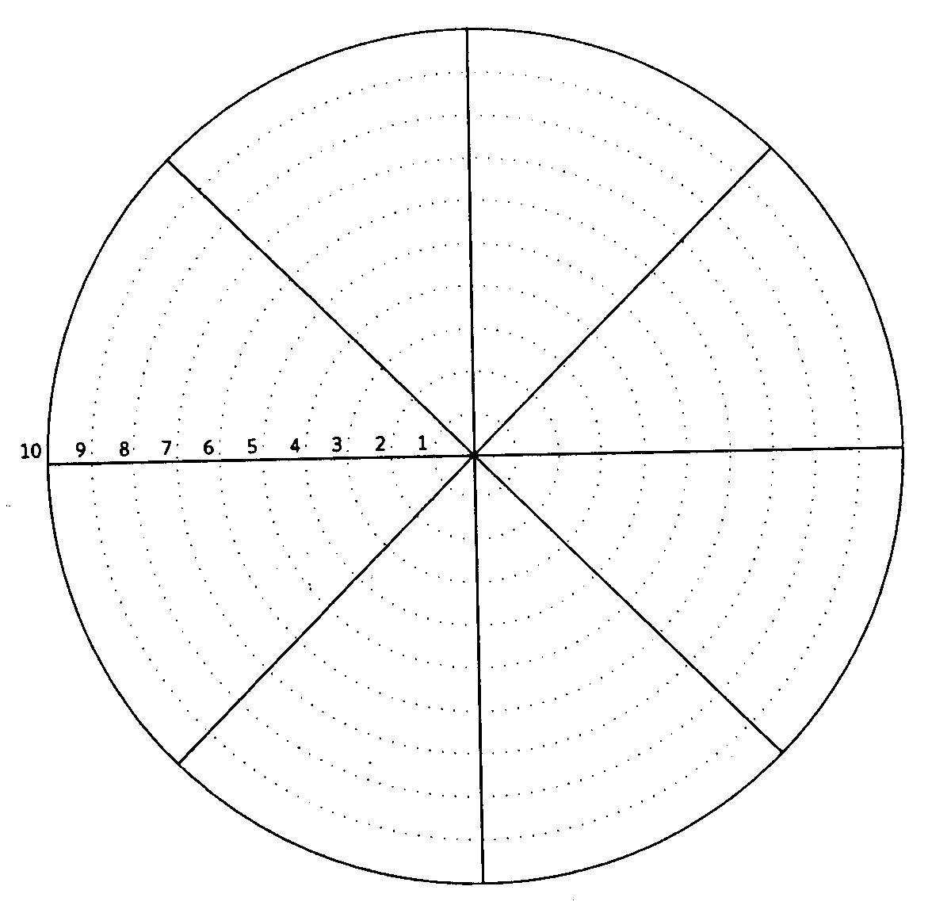

Credit Record
Budgeting

Health Benefits/
Coverage

Banking

Insurance
Retirement

Goal Setting

1. Which area do you want to improve?

[ ] Savings [ ] Budgeting [ ] Health Benefits/Coverage

[ ] Credit Record [ ] Banking [ ] Insurance

[ ] Debt [ ] Retirement

2. What financial goal could you set for that area in the next six weeks?

My goal is…

3. What could you do in the next six weeks to make progress towards that goal?

I will…

