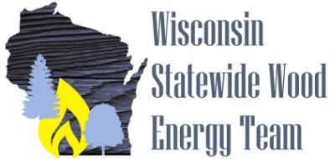
News Release July 10, 2018
Madison, WI
Are you involved in forest products? Do you produce more wood residue that you can market or have to pay to dispose of it? If so, using the residue for thermal or power applications may be beneficial to your business. On July 26 the Wisconsin State Wood Energy Team will sponsor a free webinar entitled “Wood Energy Systems and Forest Industry Companies - When Are They the Right Fit” at 9 AM CST / 10 AM EST. The main speaker will be Tom Wilson of Wilson Engineering Services. Tom has many years of experience doing assessments and designing biomass energy systems for a variety of industries and government projects. Tom will discuss the types of systems and equipment to produce thermal heat and power from biomass residues along with the benefits for the company and the community. Scott Sanford of the University of Wisconsin-Extension will discuss how to get started doing feasibility assessments and demonstrate an online tool that will help you in gathering the needed information and do the calculations so you have the information to see if it makes sense to investigate a wood energy project further.
You can register for the webinar at: https://attendee.gotowebinar.com/register/4635725033142920963
This webinar is made possible by a grant from the U.S. Forest Service. More information on wood energy can be found at www.wisconsinwoodenergy.org.
If you have questions, please contact Scott Sanford at sasanford@wisc.edu or 608-262-5062.

