  Wisconsin Nutrition Education Program  5201 Fen Oak Drive  Madison, WI 53718  Phone: (608) 224-3714 | 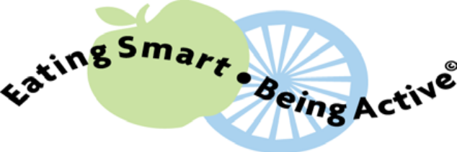  Meet Our Educators
  Kazoua Moua  (608) 224-3644  moua@countyofdane.com | Kazoua is our Hmong Speaking Educator. She serves both Hmong and English speaking residents throughout Dane County. She has been working with help build healthy families for over 12 years. Kazoua plans to teach the Eating Smart Being Active class at the Dane County Extension Office, ATTIC corrections services, Emerson Elementary School, Falk Elementary School, and SAPAR. She will also be accepting referrals to teach small groups and a limited number of in home one on one classes.
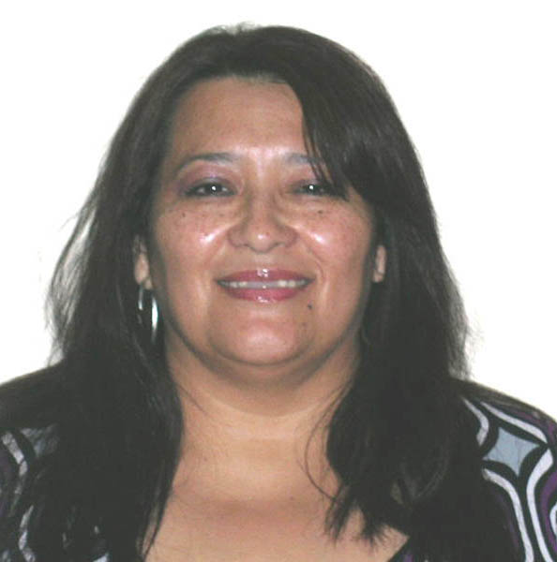  Aracely Portillo  (608) 224-3749  portillo@countyofdane.com | Aracely is our Spanish-speaking Nutrition Educator who serves the Latino community throughout Dane County. She has been working to help build healthy families in the for over 8 years. Aracely plans to conduct Eating Smart Be Active classes at Centro Hispano, Emerson Elementary, Falk Elementary, Franklin Elementary, JFF Allied, JFF Leopold, Verona Area Food Pantry, She will also be accepting referrals to teach small groups and a limited number of in home one on one classes.
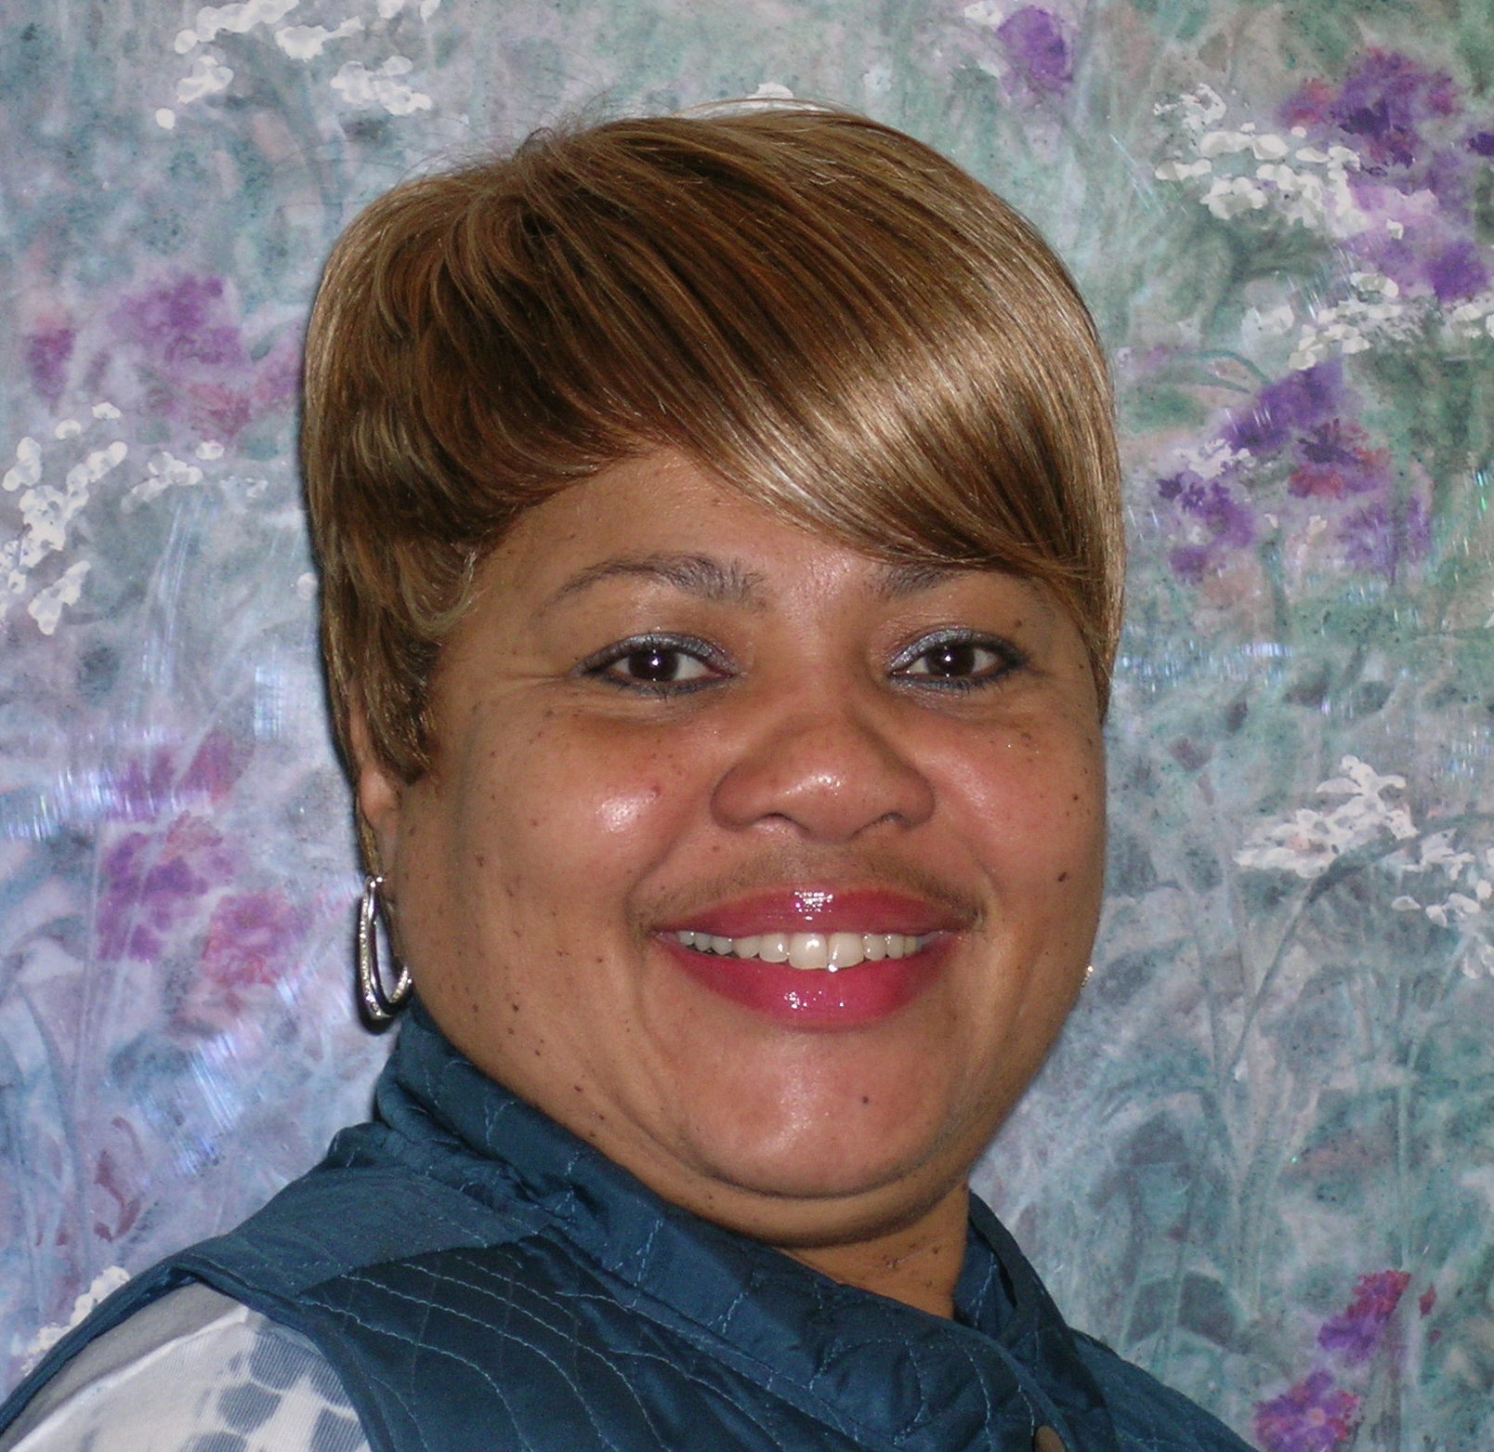  Lytonia Floyd  (608) 224-3645  floyd.lytonia@countyofdane.com | Lytonia serves residents in primarily in the South Madison and Fitchburg. She has been working to help build healthy communities in Dane county for 4 years and previously worked as a nutrition educator in Rock County for over 8 years. Lytonia plans to conduct Eating Smart Being Active Classes at ARC Maternal Infant Program, ATTIC corrections, Allied Wellness Center, Construct U, Dane County Job Center, Salvation Army, and Zion City church. She will also be accepting referrals to teach small groups and enrolling a limited number of one on one classes.
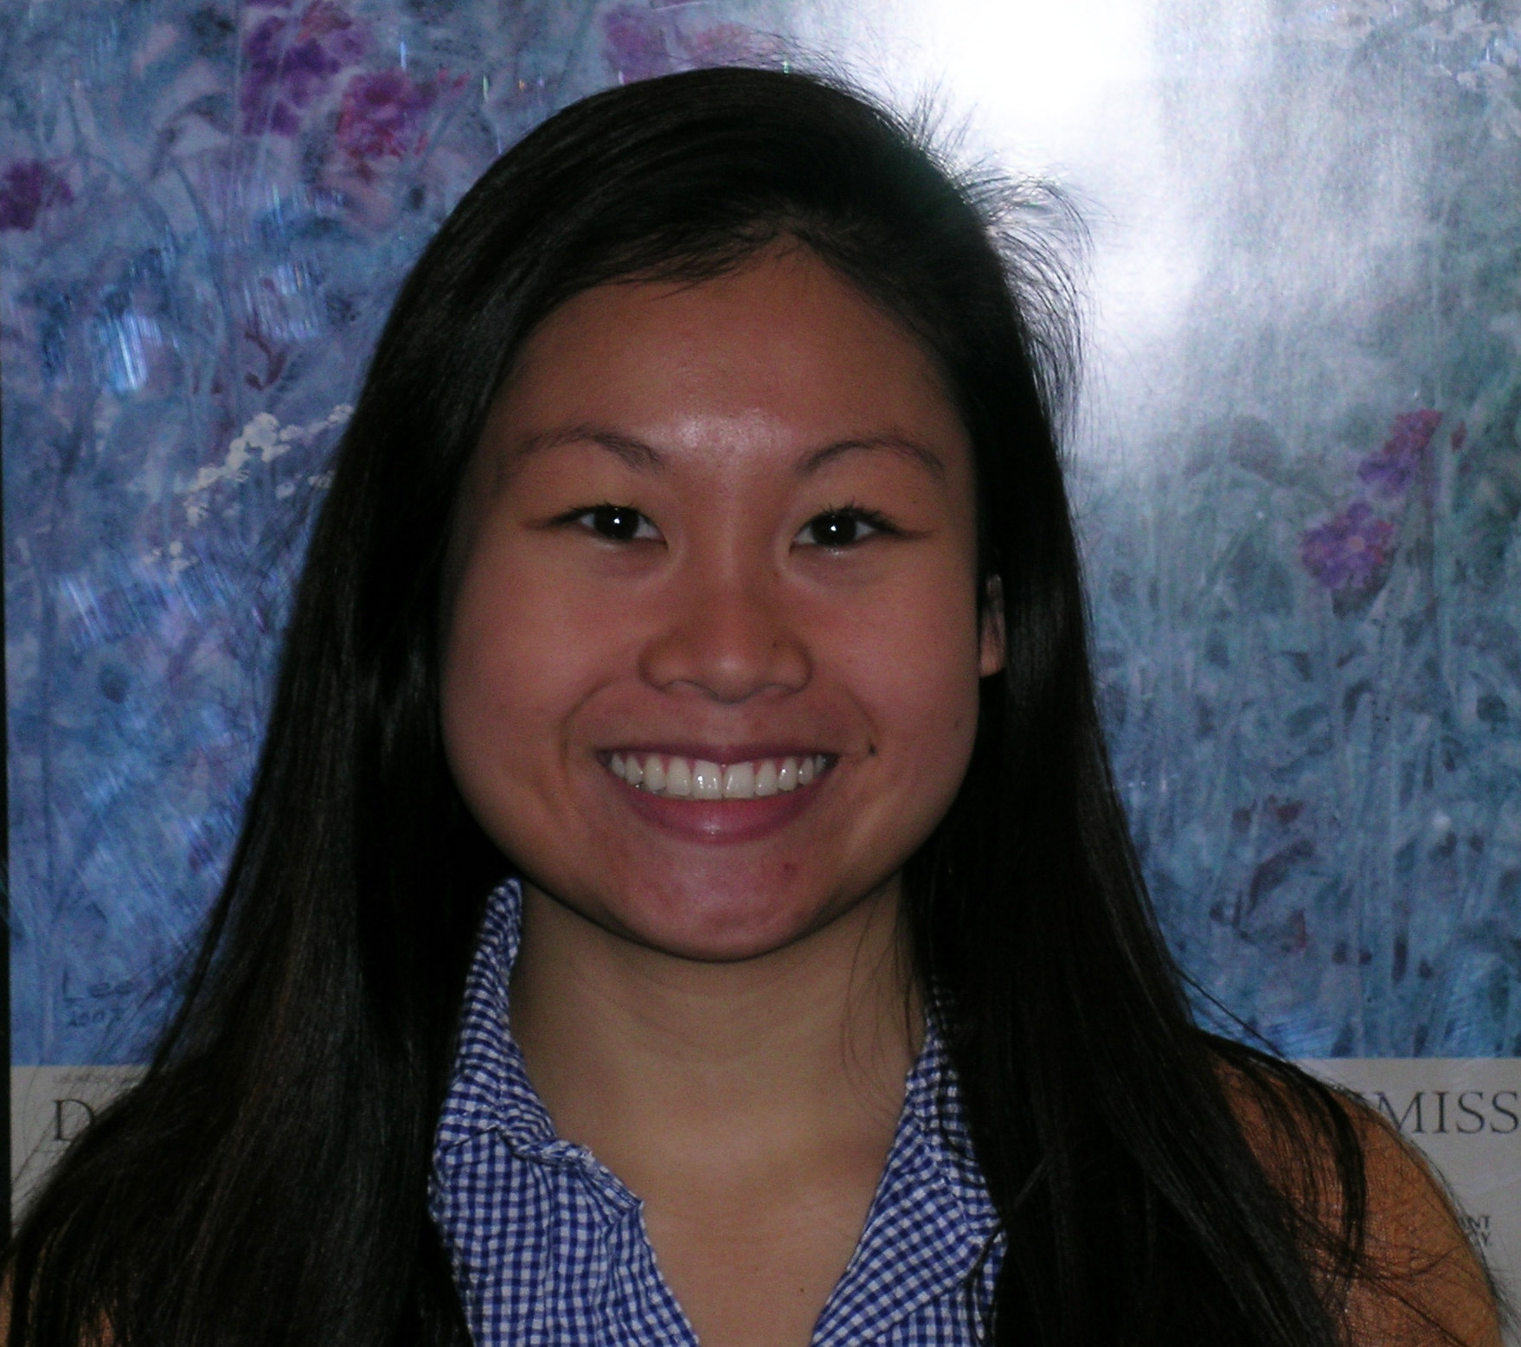  Stephanie Ong  (608) 224-3698  ong.stephanie@countyofdane.com | Stephanie is a Nutrition Educator primarily serving residents in the West Madison area and surrounding Dane County communities. She has been providing nutrition education as a Registered Dietitian for 3 years and plans to continue to help build healthy families as an educator in Dane County. Stephanie plans on conducting the Eating Smart, Being Active series at the Dane County Extension Office, apartment complexes in the community and local community centers. She will also be accepting referrals to teach small groups.

