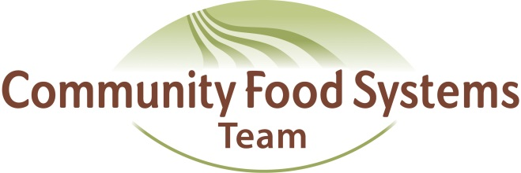

Community Food Systems Team
Second Annual Face-To-Face Meeting
September 4-5, 2013
Central Wisconsin Environmental Station, Amherst Junction

Meeting Objectives:
- Increase knowledge of activities by team to date, new structures and programming opportunities
- Increased inter-county and inter-program networking, collaboration, and engagement
- Catalyze collaborative, interdisciplinary programming
- Fun

SEPTEMBER 4, 2013

11:30–12:30PM Arrival and registration (arrive early to pick up bedding and
locate room arrangements)

12:30-1:30PM Lunch – Welcome and Introductions

1:30-2:15 PM Icebreaker: 4 corners activity

2:15-3:00 PM Team update: CFS Team Jeopardy

3:00-3:30 PM Break

3:30-5:00 PM 10 x 10 presentations-UWEX educator presentations from different program areas

5:00 PM Break &Networking

6:00 PM Dinner

8:00 PM Bonfire

SEPTEMBER 5, 2013

7:00-7:45 AM Breakfast

8:00-9:30 AM 10X10 Presentations + Panel Discussion
Pamela Hobson-4-H Youth Development -Moderator
Michelle Miller-Center for Integrated Agricultural Systems (CIAS)
Julie Dawson-UWMadison-Dept of Horticulture
Jed Colquhoun-UW Madison- Dept of Horticulture
Lynn Markham-Center for Land Use Education
Steve Deller-UW Madison-Dept of Ag and Applied Economics

9:30-9:45 AM Break

9:45-11:00 AM Whole Measures-strategic evaluation frame
Prezi, gallery walk, debrief

11:00-12:00 PM 10 x 10 presentations-UWEX educator presentations from different program areas

12:00-1:15 PM Lunch

1:15-2:15 PM Open Space
Confirmed topics:
community gardens
food waste programming in schools

2:15-2:45 PM Break

2:45 – 3:30 PM Open Space

3:30 – 4:00 PM Next steps and closing

