Money $mart in Head Start
Financial Survey

We are inviting you to fill out this survey because it will help us improve our future UW-Extension financial education programs and provide the services to help you reach your financial goals.

Your decision to participate in this survey is completely voluntary. Any information you provide will be combined with all the other survey responses received, so that only group information will be shared. Although we ask for your contact information, you may choose to include it or not. Your contact information will be used to get in touch with you about our financial education programs and to send you another follow-up survey in spring. Responses will be separated from your contact information to protect your privacy. We do not expect any privacy risks to you if you complete this survey.

If you have any questions about this survey, please contact your local UW-Extension Family Living Agent/Educator (local name & contact phone or e-mail address goes here) or call UW-Extension Family and Consumer Economics Specialist J. Michael Collins at (608) 262-0369.

If you choose not to participate in this survey or choose to skip any or all of the questions, it will have no effect on any UW-Extension educational programs or services you are currently involved with or any future educational programs that you may participate in.

Returning the survey indicates you voluntarily agree to participate in the survey.

Thank you for your time. We appreciate your input.

Sincerely,

(Your name/title)

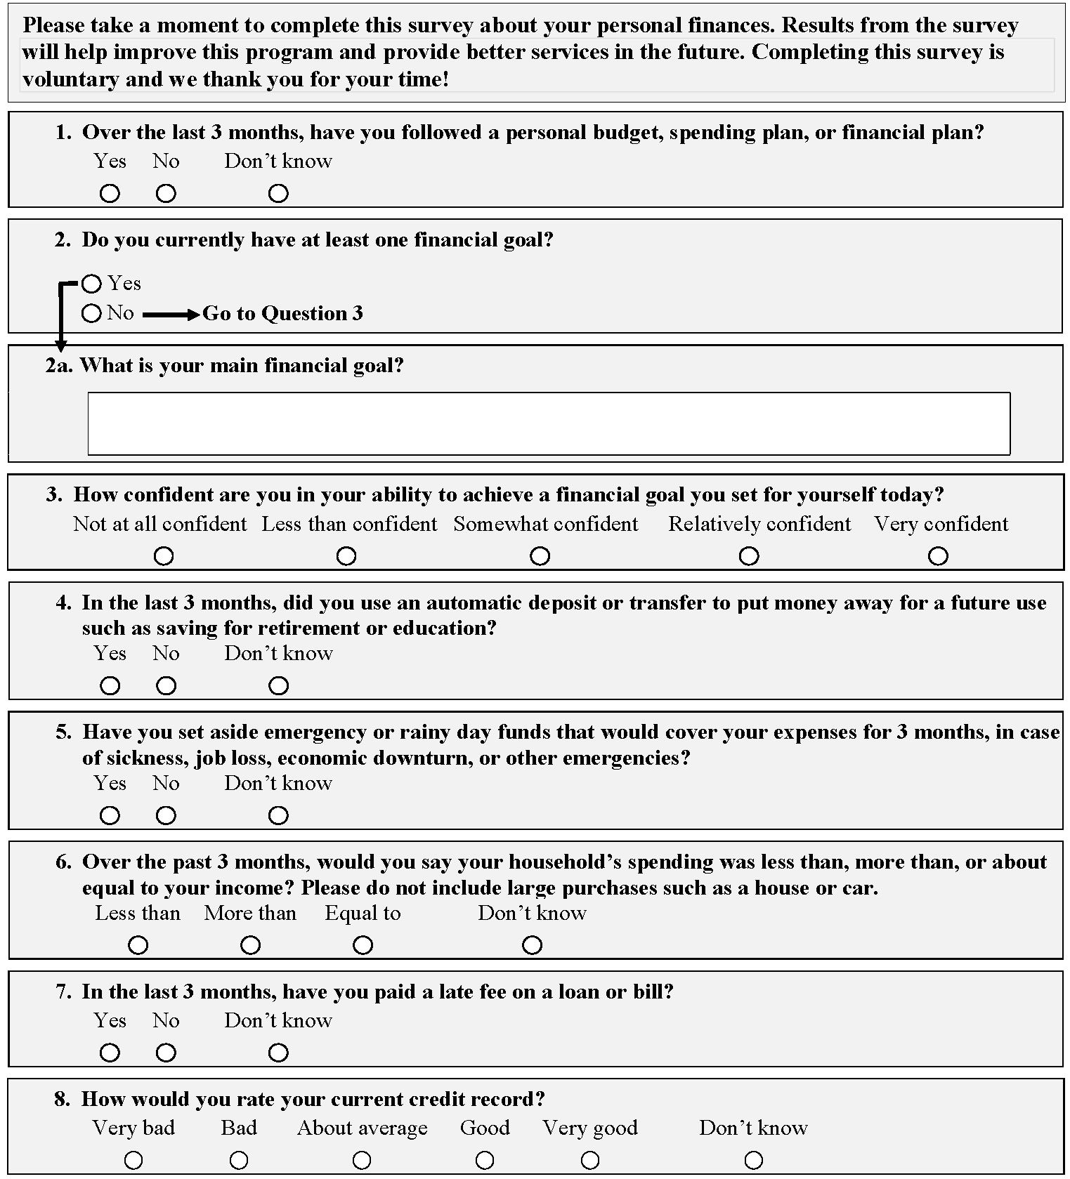

Money $mart in Head Start

CONTACT INFORMATION

We ask for this information so that UW-Extension can follow-up with you about our financial programs. To protect your privacy, your contact information will never be matched to your survey responses. Your contact information will only be used for educational programs.

Name: _________________________________________________________

Home Phone: ____________________________________________________

Work Phone: _________________________________________________________

Cell Phone: ____________________________________________________

Email: _________________________________________________________

Which number is best to contact you: [ ] Work [ ] Home [ ] Cell

Best time of day to contact you: [ ] Morning [ ] Afternoon [ ] Early evening

Home Address: __________________________________________________

City/State/Zip: __________________________________________________

County: __________________________________________________

Please return your survey in the return envelope provided.
You’ll receive a second survey next spring.
Thank you!

