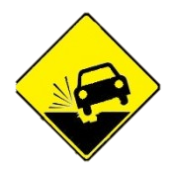
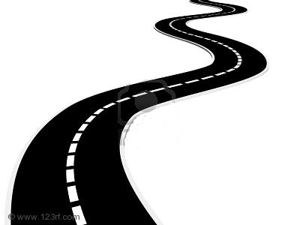

Ideal Self Destination
3 Years
DETOUR
1 Year

Ideal Self Destination:
You are driving down an endless road. As you approach the road signs along the way, you reach different destinations of your ideal self in the future.

At the first road sign, draw a picture of yourself or write down words that describe you one year from now.
What are you doing? Where are you? What are you happy about?

As you a driving down this road, there are bound to be some bumps, potholes, or road construction on the way. Draw a picture or write down your thoughts in the detour and pothole signs.
What are some obstacles you might face as you approach this first year of your ideal self?

Now, imagine you are back on the road and driving towards your ideal self in 3 years. Draw a picture or write down your thoughts in the next road sign.
Again, what are you doing? Where are you? What is different?

