***Add date***

Community-Led Research to Support Business Retention, Expansion and Recruitment Efforts

**Downtown YOUR TOWN   
*Retail Demand and Supply Analysis***

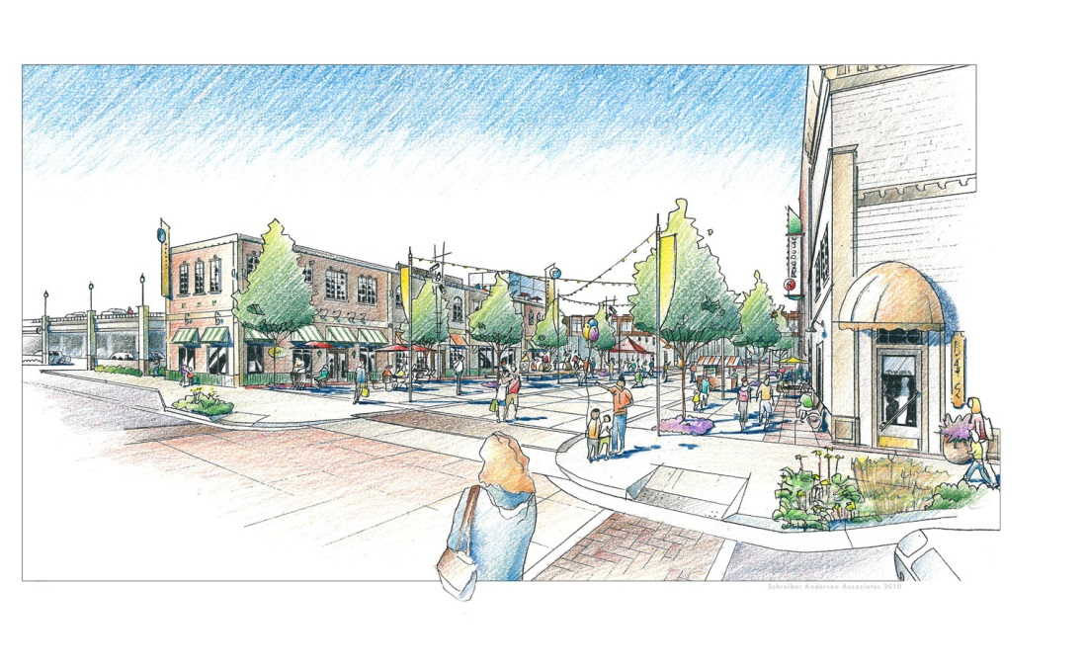

Add your town’s photo here

Add your organization’s logo here

Methodology developed by Bill Ryan of the University of Wisconsin-Extension, Center for Community and Economic Development. It is applied her by (add your towns organization)

Retail Demand and Supply Analysis

This report provides estimates of market demand and supply for retail and eating/drinking places in downtown YOUR TOWN (the Study Area). It examines business opportunities in terms total sales potential and number of business equivalents. Findings can be used to inform business attraction efforts by demonstrating:

* A shortage of certain business categories downtown, or
* A concentration of certain businesses that might define a market niche downtown.

Demand is the amount of a good or service required to fulfill the needs of customers in your area. It is mainly driven by the number of customers in the Trade Area and their purchasing power. Demand is also a function of the number of office workers and tourists visiting downtown. Again, demand is measured here in terms of sales and store equivalents.

Supply is the amount of a good or service currently serving the market. It too can be measured in sales and number of stores.

**Measuring Opportunities in the Study Area**

The following approach for estimating demand differs from many traditional methods. First, demand is estimated for the downtown YOUR TOWN Study Area based on a “proportionate share” of the entire Trade Area. Secondly, it excludes demand from large format stores that typically do not locate downtown. Finally, the following approach looks beyond local resident demand to include other market segments including downtown workers and tourists.

**Key Assumptions Used**

* The 2012 U.S. Economic Census of businesses with employees reasonably reflects resident behavior in the Trade Area.
* Trade Area resident spending is adjusted through modifications for income and lifestyles relative to U.S. averages.
* Downtown’s ability to penetrate the Trade Area’s overall demand is a function of its commercial activity (and/or commercial space) as a share of the total Trade Area.
* Demand for other market segments (office workers and tourists) are estimated using state and national data describing their spending behaviors. Adjustments are made to reflect downtown’s ability to capture their spending potential.

**NAICS Categories Analyzed**

This analysis provides an estimate of demand and supply in downtown YOUR TOWN for 14 categories of retail and eating/drinking places.  Most of these categories are presented at the three-digit NAICS level. The categories used (see following page) reflect the types of businesses found in many downtowns. Again, various categories are adjusted to exclude large format stores including home centers, supermarkets, warehouse clubs and supercenters.



**Downtown YOUR TOWN Study Area**

The Downtown Study Area used in this report follows that of the Downtown YOUR TOWN Business Improvement District. This is the geographic commercial district, which is the focus of this study. See the accompanying map.

[ADD DOWNTOWN STUDY AREA MAP]

**Downtown YOUR TOWN Trade Area**

A Trade Area is the geographic area from which a community generates the majority of its customers.Knowing the size and shape of the Trade Area is important because it allows for measurement of the number of potential “resident” customers and their spending potential.

To define the Trade Area, an equal competition area was used.  This Trade Area is formed by lines drawn exactly halfway between each of the competing destination commercial centers (defined by Walmart Supercenters). Any point within the equal competition area is closer to downtown YOUR TOWN Study Area than any of the surrounding commercial centers.

[ADD TRADE AREA MAP]

**Market Segments**

The analysis that follows estimates downtown’s potential to capture spending from three market segments. These segments include:

* Residents of the Trade Area
* Workers of all employers in the Downtown Study Area
* Visitors including leisure and business travelers to the County

*Note: the Downtown YOUR TOWN Study Area is also referred to as the subject “Study Area.”*

**Trade Area Resident Demand**

The demand for the subject Study Area is based on a “proportionate share” of the broader Trade Area as defined earlier. Typically, not all categories are represented by the same Trade Area as some stores pull from a larger “destination Trade Area” while others pull from a smaller “convenience Trade Area.”  For purposes of this analysis, YOUR TOWN’s Trade Area was used as a basis for this demand analysis. The subject Study Area will compete for a share of this demand.

Consumer spending potential for each business category reflects the following assumptions:

|  |  |  |
| --- | --- | --- |
| **Assumption** | **Description** | **Amount** |
| Population | Number of residents in the respective Trade Area. | 82,616 |
| Spending Per Capita | U.S. sales in each store category (per the 2012 US Economic Census) divided by U.S. population. | Calculation |
| PCI Index (U.S.=100) | The per capita income in the Trade Area indexed to the U.S. per capita income (per the most recent US Census). | 99 |
| Behavioral Index (US=100) | A local modifier of consumer behavior indexed to the U.S. average consumer. This factor accounts for other demographic and lifestyle factors that would increase (>100) or decrease (<100) a person’s likelihood to purchase in a particular business category in the Study Area. | 87 |
| Trade Area $Potential | Multiplication of the above variables. | Calculation |
| SA/TA Establishments | A measure of the current commercial activity based on the number of businesses (or retail square feet) in the Study Area (SA) as a percent of those in the Trade Area (TA). This is also defined as “proportionate share.” | 12% |
| Study Area $Potential | Multiplication of Trade Area $Potential and SA/TA Establishments produces Trade Area resident demand that could reasonably be captured in the Study Area based on its proportionate share. | Calculation |

**Study Area Worker Demand**

Study Area worker demand potential is based on the number of employees in the district, multiplied by office worker spending as estimated by the International Council of Shopping Centers (2012). Sales are then allocated among the retail and eating/drinking place categories in proportion to Trade Area resident spending. A local modifier or behavioral index (US=100) is applied to account for the amount of retail and dining offerings in the subject district relative to other office districts in the country.

|  |  |  |
| --- | --- | --- |
| **Assumption** | **Description** | **Amount** |
| Worker Population | Number of employees in the Study Area. While many are also Trade Area residents, their extensive presence in the district may reflect spending potential over and above that of residents. | 3,000 |
| Spending Per Year | U.S. annual sales in each store category are based on estimates by the International Council of Shopping Centers (2012). They are distributed in part according to the 2012 US Economic Census. | Calculation |
| Behavioral Index (US=100) | Behavioral Index (US=100) is applied to account for the amount of retail and dining offerings in the subject district relative to other office districts in the country. | 100 |
| Study Area $Potential | Multiplication of the above variables. | Calculation |

**Visitor Demand**

Overnight and day visitor demand potential is based on YOUR STATE Department of Tourism traveler spending estimates for YOUR TOWN County.  Sales are then allocated among the retail and eating/drinking place categories in proportion to Trade Area resident spending.  A percent of these sales was allocated to the Study Area based on number of restaurants in the Study Area as a percent of those in the county (SA/Co Estab.). A local modifier, Behavioral Index (Co.=100) is applied to account for attributes of the Study Area as an inviting place for visitors relative to the county as a whole.

|  |  |  |
| --- | --- | --- |
| **Assumption** | **Description** | **Amount** |
| Annual Visitor Spending-County | Direct annual spending by visitors in county as reported by the State Department of Tourism. These visitor sales are then distributed in accordance with all sales reported by the 2012 U.S. Economic Census. | Calculation |
| SA/Co. Establishments | A measure of the current hospitality industry activity: the number of eating/drinking places in the Study Area (SA) as a percent of those in the County (Co.). | 16% |
| Behavioral Index (US=100) | Behavioral Index (US=100) is applied to account for attributes of the Study Area as an inviting place for visitors relative to the county as a whole. | 125 |
| Study Area $Potential | Multiplication of the above variables. | Calculation |

**Total Study Area Demand**

The spreadsheet on the following page applies the calculations in this report to arrive at sales potential for 14 retail and eating/drinking place categories. Sales potential is then used to estimate an equivalent number of businesses that could be supported by these sales.

Demand potential from each segments reflects dollars that could be captured in the downtown Study Area, not the entire Trade Area.  It represents a realistic attempt to measure spending that could be captured in the downtown area alone. Again, to make the analysis most relevant to downtowns, it excludes spending at large format stores.

Dividing $Demand by the average sales per U.S. establishment (per the 2012 US Economic Census), results in the generation of a rough estimate of the number of stores that can be supported in each business category.  While there are significant limitations in using such averages (sales vary widely among businesses in each category), it does provide a starting point for the comparison of demand with actual supply/existing businesses.

**Conclusions - Comparing Demand and Supply**

Based on U.S. spending patterns adjusted for local conditions and excluding most large format store categories, the Study Area has approximately $xx Million in retail spending potential. This is approximately xx retail operations (based on “average” U.S.. sales per business category). Currently there are xx retail operations in the district.

Based on U.S. spending patterns adjusted for local conditions, downtown YOUR TOWN has approximately $xx Million in eating and drinking place spending potential. This is approximately xx operations (based on “average” U.S. sales per business category). Currently there are xx eating and drinking place operations in the district.

(Add concluding discussion….) Based on demand and supply differences, there appears be …..

Replace this page with 11x17 printout of accompanying Excel spreadsheet